**2024 NextGen Users Conference (Dec 11, 2024)**Session Notes

|  |
| --- |
| **HIGHLIGHTS**  Features on new release   * Ability to have person in workflow without them having to sign * TRUE proxy - users would be able to alter their account to request a person to be proxy in their absence (while on vacay, etc.) & that 2nd person/user would have to accept that request. And then, they could sign for the person while they’re out on vacay. Details * Auto-escalation – you’ll be able to configure a form to wait for a signature for a certain amount of days…and if it doesn’t get the sig within that timeframe, you have another person’s email configured on the form for it to be escalated to…so that the form gets processed.   Form Warehousing  Basically, they’re now making it possible to retrieve already-warehoused forms (forms older than 2 years) while in the product. Of course, users wouldn’t be able to “interact” with the form, but only view it.  Library (Forms Store)  They have a lot of pre-made forms and they’re now going to sell them in the “Library”. ALSO, if we make a form, we can sell it on there too. Many of the folks thought it was stupid for them to be sold..and just thought they should be offered there. But even if other orgs place their forms there, you can set the price to zero so that there’s no charge for someone to get it.  Student Verification (Fin Aid)  So NextGen has an entire programmed area strictly for Student Financial Aid…and they displayed/demo’d it.  Form Invitations  These are cool and I could see use for these. Let’s say that TSU wants everyone to complete a “Conflict of Interest Form”, it could be set up here and that way, you’d have tracking of how many folks actually clicked the link in the email that went out about the form. And I believe it tracks in a special way each person & shows if it’s been completed by them or not. I received a call yesterday to an “Emergency” meeting for that pres resigning dealie…and so I missed that part of the training. But the recording should be coming out soon and I’ll re-look at that…and I’ll post it so that we all have it available to us.  Questions & Answers from Session’s Chat  (questions that other univs and orgs asked and how NextGen answered)  FYI  Hey, I re-mentioned to them that we have a need for “packets of forms”…like for the HR Employee Onboarding Process…that will track all forms in the packet & notify HR when they’re all been signed…and/or alert HR when they haven’t been signed/submitted by a certain date, etc. They know about this suggested product enhancement…but haven’t implemented it yet.  Form Versioning: They DID mention their lack of form “versioning”…which has always driven me crazy. So they may venture into creating versioning of the forms. Jim Grace said, “We’ve gotten away with having no versioning every since the inception of the product.”…and that it might need to be addressed now. |

Can create user groups in DF and control who gets notified. (All want to be able to interact with form…but only one person or whatever need to receive the email.)

So the others would still be able to login to DF & look at & interact with that form.

You’ll be able to designate up to 3 proxies in your account. So if you go on vacay, you just assign a proxy to sign your forms while you’re out. The 2nd person (backup person) has to accept the responsibility in the system.

If a proxy is in place, both the original person & th3 2nd (proxy) receive the emails

**AUTO-ESCALATE**

A feature has been added that allows you to set a number of days on a form…and if it hasn’t been approved, it escalates to the person listed.

**CONDITIONAL LANGUAGE WITHIN EMAIL**

**FORM WAREHOUSING**

2 years of data are shown on homepage….for decent performance of product, rather than being bogged down.

Then, after 2 years, form is warehoused.

(Years 3-7 of form submissions are still in the system; Just have to search for them differently)

NEW FEATURE:

Click on “Filter” and there is now a “Warehouse” item….that allows you to see older forms as well.

(this is not allowed to be saved as a preference)

….and there’s now a checkbox for “Include forms older than 2 years” on specific form’s queues.

NOTE: If the form is beyond 2 years old, you CANNOT interact with it (IE, sign, process, etc)

MASS APPROVAL ENHANCEMENTS

Mouse-over to display key fields that need to be presented in order for a manager to approve. With this, you’d have approve/reject and you’d have a box to type why you rejected it.

**LIBRARY (FORMS STORE)**

Pre-made forms for sale. Or you can post forms too & put a price on them. You can put zero as price if you just want it to be free for others to use.

**PRODUCT ROAD MAP**

**DYNAMIC VERIFICATION PRODUCT (STUDENT FIN AID VERIFICATION)**

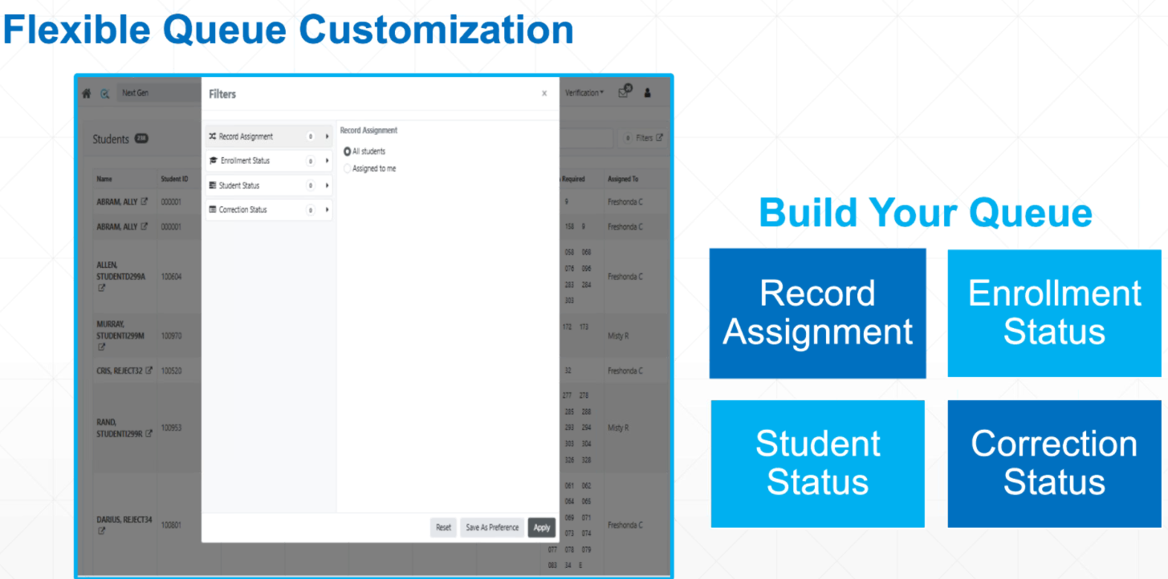

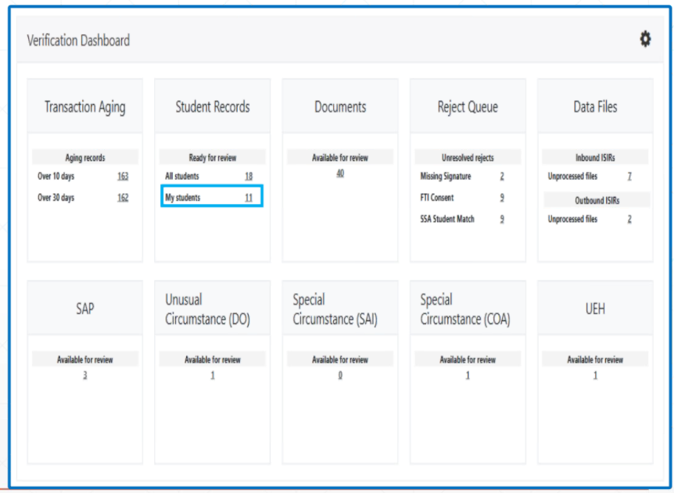

**FORM INVITATIONS**

If we want to use, need to let NextGen know for setup. (no cost)

CSV file – of contacts w/ email address; must have header row as well

ADMIN dropdown – “Upload files”

Basically, it’s good if you need many folks to sign a document & want to track who has & who hasn’t.

FORM INVITATIONS DASHBOARD

Simply shows who clicked the link in the email.

_____________________________________________________

**QUESTIONS & ANSWERS**FROM CHAT DURING USER CONFERENCE

**Audience Question**

**Q: Is this going to be recorded? I will have to log off from 2:30-3:30**

A: Yes, the full meeting will be available via the online help area as soon as the recording  is ready and we can publish it there.

**Audience Question**

**Q: Can I get a link to the Online Help Area where the recordings will be posted? Thank you!**

A: You can access the online help area from the Administrator Home page and by clicking the question mark (?) in the upper right corner of the page. The recording will be made available under the Training / User Group chapter.

**Audience Question**

**Q: I know it is early for a question but yesterday I was asked if there is a way to recall a form to make changes after the final approver has approved it. I only saw archive or delete as options, but not a resend for corrections. The final approver could not get in because it said she had already signed.**

A: What you can do is return the form to the final approver.  You can do this by accessing  the form instance in the queue that it is in (pending/processed). You will click the PDF of the form. From the Action menu in the upper right of the page will have a Return for Revision option.  You can find more information about this in the online help area under the Building Forms chapter and the Return for Revision article.

**Audience Question**

**Q: Are all these partipants besides owner ?**

A: Yes

**Audience Question**

**Q: With the new feature, what will the default be for Submission Type?**

A: Hi Sue:  Default will be E-Sign (and authenication) - Form Designers will need to purposefully change that to use No Sign

**Audience Question**

**Q: How do we join the listserv?**

A: To sign up for the DF User Group Community/listserv, click the following URL: https://dynamicforms.ngwebsolutions.com/Submit/Form/Start/5f6911fc-8e01-4833-9660-c5e81c55f8a5  
Fill out the form and submit and an admin will admit you.

**Audience Question**

**Q: How do we join the listserv?**

A: You can use this form to request to join: https://dynamicforms.ngwebsolutions.com/Submit/Form/Start/5f6911fc-8e01-4833-9660-c5e81c55f8a5

**Audience Question**

**Q: Is it possible to have one person fill out a form, send it to another person to have them finish filling it out, then return it to the first person so that they can submit the form? I'm looking at it from a student to advisor, back to student, and submit it to our ofice. Hope that makes.**

A: Yes, for the example you provided, you would  need to add the first person as a 3rd participant so that the form is sent back  to them to finish completing any additional fields and submit.  If you need further assistance with this you can email support@ngwebsolutions.com and one of our team members can help.

**Audience Question**

**Q: Is it possible to have one person fill out a form, send it to another person to have them finish filling it out, then return it to the first person so that they can submit the form? I'm looking at it from a student to advisor, back to student, and submit it to our ofice. Hope that makes.**

A: Hi Jeremiah:  You can do this today with conditional workflow - say - if the first user requests help, the form can be routed to the helper.  Then the same thing with Helper choosing to send it back to the initial user.

**Q: Did you just say that the folks who are in a usergroup who do not get emailed....will still the the form in their listing of forms that need their signature? I missed that.**

**Q: okay, she just answered it. I'm good. :)**

**Audience Question**

**Q: Thanks for your work on this!  Most of our use cases where the no-authentication, no-signature workflow would be useful is where every participant in the workflow wouldn’t require a signature.**

A: Thank you Nicole - we will have all options for you, but have instructions e-signature validity on forms where we have a user without authentication.  The issue we are working with the legal team is that e-signers assumption that one person is asked to sign the form, but not having previous participants authenticate (so you do not really know who submitted the form).   We'll have this figured out soon.  Attorneys do not work super fast - sometimes!

**Audience Question**

**Q: I have another question. So sorry. I am carbon copying all form signers to receive the form when the final signer signs. The problem is that the form is conditionally formatted. If a studnet selects BS degree it goes to one person and if it is MS degree it goes to another. From there they both go to the same final approver. On the carbon copy I could not find a way to have it sent to signer A if BS is chosen and signer B if MS is chosen. I could only choose the users, so I chose all of them. One is mad because she receives all forms now and only wants her students' forms. Can I note in carbon copy to only send forms meeting this condition to this person and others to another?**

A: Hi Kelly. Conditional cc's will  be included in our next release.  I believe we will be covering information about this later on in the call.

**Audience Question**

**Q: Is this session being recorded?**

A: Yes, the full meeting will be available via the online help area as soon as the recording  is ready and we can publish it there.

**Audience Question**

**Q: We debatted creating a new form for signer B but students don't always know if they are a BS or MS degree before beginning the form so we need students to fill out the same form in case they have chosen incorrectly. So, the signer is out of luck.**

A: If you would like to get assistance or suggestions for your form, you may email support@ngwebsolutions.com and one of our team members can help.

**Audience Question**

**Q: who has the permssion to update the proxy under user profile ?**

A: The user will add users they want to allow to act as a proxy.

**Audience Question**

**Q: Are there any ways to restrict proxy participants if Org wants to manage that Users may only choose proxy's that are at their level or above?**

A: Not currently but would be interested  in hearing more about what you are thinking. Please email support@ngwebsolution.com with additional details and our team can review.

**Q: ON PROXIES --When the original approver receives the email (at the same time that the proxy is receiving the email), does the original approver also receive an email stating that the Proxy took care of the form....or will the original approver feel that they need to click the link in the email & check it to see if it's been handled already?**

**Audience Question**

**Q: For Proxys, is that something that can be controlled from an Admin level. So the Admin turns it on/off instead of the individual user?**

A: Hi Gloria:  Form Designers can decide if they wish to allow Proxies on the form or not.   We don't have an Proxy Filter now - I would be interested discussing how we can do that with you and the team.

**Audience Question**

**Q: So is the proxy access limited to by form, or will it be on all forms?**

A: Hi Mike:   yes, the form designer can choose whether to allow Proxies or not - the default is "No"

**Audience Question**

**Q: Will that notificaiton to the proxy indicate they are a proxy or will it be the same co-signer email the original participant gets?**

A: We are still in the development of this feature. At the moment, I believe that the proxy will understand they are being contacted as a proxy for the participant.

**Audience Question**

**Q: Will that notificaiton to the proxy indicate they are a proxy or will it be the same co-signer email the original participant gets?**

A: Great question and feedback Kevin:   We will look to customize the proxy email to highlight that.

**Audience Question**

**Q: What is the benefit of using Proxy over User Groups?**

A: Using a proxy will allow users to sign on behalf of another user. An example might be if a VP wanted their executive admin to be able to sign on their behalf they can.

**Audience Question**

**Q: Can an Admin maintain Proxies. E.G the proxy originator no longer works at the orginazation?**

A: No, on the the individual user can maintain who can act as a proxy on their behalf. If the proxy originator no longer worked at the organization then the form participant would need to be updated to be a different person.

**Audience Question**

**Q: who do we reach out for administrator support and training?**

A: You can  email support@ngwebsolution.com and one of our team members can assist.

**Audience Question**

**Q: Is there a way to restrict which forms the proxy can sign? For instance if someone only wants a proxy one specific forms and would rather not have proxies on others, would that be possible?**

A: Yes, the form designer can choose whether to allow Proxies or not - the default is "No"

**Audience Question**

**Q: Auto-Escalate - it would be very helpful to be able to designate who to route to from fields on the form and not hard-coded.  So it can go back to a prior participant or someone in the workflow.  Would make it more dynamic as some of our forms are being used across multiple divisioins.**

A: Thank you for this idea Mike. We will review this suggestion to see if it is something we can include in this release.

**Audience Question**

**Q: please share all the slides for this meeting**

A: A full recording of the video will be included in the online help area once the recording is available.

**Audience Question**

**Q: Can hyperlinks be included in the customized emails?**

A: Yes, they can. There is a hyperlink tool in the rich text editor provided when customizing emails. If you have further  questions about this you can email support@ngwebsolutions.com.

**Audience Question**

**Q: I have a question about that link that is included in the email to look at the form, many users report it not working for them. What is the cuase of that and what is the fix?**

A: There can be different things that can cause the issue.  Please email support@ngwebsolutions.com with a form example and full details around who can't see the form and what they are experiencing. We can then troubleshoot and provide further assistance.

**Audience Question**

**Q: Does Dynamic Forms have the capability to pull info/data from Cornerstone?**

A: We can typically integrate in this way through the use of APIs.  Please email support@ngwebsolutions.com with what you are looking to do and one of our team members can assist.

**Audience Question**

**Q: For the Proxy functionality is there a risk that a person can assign a proxy and use an email address that is a personal email address and not the College email address?**

A: If the form requires SSO authentication, a personal email address would not be able to be used as the user wouldn't be able to authenticate into the form.

**Audience Question**

**Q: Any thoughts on adding an  "undo" for some functionality- like accidentally deleting an item and we want to undo the delete ...???**

A: This is something we have on our list of potential enhancements we are tracking to consider for a future release.

**Audience Question**

**Q: Can we touch on the usability of forms on mobile devices? I have been noticing how forms may look very different on mobile devices which is where we expect many student users to access it from. I see differances particularly with charts. Is there certain training I am missing to minimize these issues? Or will there be any development in allowing form developers to toggle between desktop and mobile view so we can predict how it looks?**

A: Forms should be compatible with any of the various devices users are utilizing to complete them. Please email support@ngwebsolutions.com with a specific form example where you feel it isn't rendering as expected. One of our team members can review the design and offer suggestions on the design that will help.

**Audience Question**

**Q: Would ya'll be so kind as to send a hyperlink to that online help area?**

A: The online help area can be accessed from the Administration Home page and by clicking the question mark (?) in the upper right corner of the page.

**Audience Question**

**Q: How long are warehoused forms stored (or how far back do they go)? Thanks!**

A: Form data is stored for a total of 7 years. Once forms move to the warehouse they will be stored for 5 years. After the form data is deleted.

**Audience Question**

**Q: can you email us the presentation file please?**

A: A recording of the full presentation will be made available via the online help area and the Training / User Group chapter once it becomes available after the meeting.

**Audience Question**

**Q: Had to do my search of warehoused forms yesterday and the new enhancements look great!  If we bring the warehoused forms back into the queue - we would be able to dump the data into the csv from there as well, yes?**

A: That is correct. You can export the warehoused form data from the queue.

**Audience Question**

**Q: Can you price the form at $0?**

A: Hi Jessie:   Yes!  I will go through that in a couple of minutes

**Audience Question**

**Q: If a school sells a form, how would upgrades to the form work?**

A: Hi Shantie:  Great question - once the form is "purchased", they purchaser will recieve a copy of that form, so they can update anything they wish - the original form will not change.

**Audience Question**

**Q: I meant if the school had an upgrade to a form that another school purchased and wanted to share the upgrade. How will that work? Will it be a new form?**

A: Yes it would need to be a new form. The original form could be removed from the library and then replaced with the new form.

**Audience Question**

**Q: what about the PAI and participants information , workflow information in the form library ?**

A: All forms avaialable in the library for purchase will have been sanitized to remove any API events and specific participant information.

**Audience Question**

**Q: How can we remove a shared form?**

A: You will be able to contact support@ngwebsolutions.com to have a form you offered via the library removed.

**Audience Question**

**Q: I've always loved that NextGen provides a community for each other to share forms and knowledge freely and this just seems like a way to monetize and is unfortunate. It's not a "library" at that point but a store.**

A: Thanks Melissa - as I mentioned, this is a new feature and it will evolve over time based on our user community's feedback

**Audience Question**

**Q: I would want to be able to see the full functionality of a form before being purchased, not just the submitted form.  Can there be options to 'test' the functionality before purchasing?**

A: Thanks Carol - we will look to see how we can do this better also

**Audience Question**

**Q: Will the template be able to include ethos calls (without auth)/filters/etc that the form uses?**

A: The form provider will be able to filter all or some of the parts of the form - there are two reviewers - the form designer and Next Gen - we will review to ensure no school data is included in the form also.

**Audience Question**

**Q: where is this located?**

A: If you are referring to the API screen Martin is representing, this is the API Admin page.  Admin users need API admin permissions to access it.

**Audience Question**

**Q: Once the form is purchased can you share it to any group within our organization?**

A: Hi Amaris:   Yes, once the form makes to you, you can share will anyone you like (you would need Admin permission to move the form from org to org)

**Audience Question**

**Q: Last year's Road Map was projecting we would be epxecting release 13 around this time. How many releases should we be expecting per year?**

A: Hi Jason:  I think it was a mislabeling of Release numbers on the roadmap - we have corrected that

**Audience Question**

**Q: Last year's Road Map was projecting we would be epxecting release 13 around this time. How many releases should we be expecting per year?**

A: We typically have 2-3 major releases each year - last year was a bit different as we moved the entire platform from on-premise servers to the Azure platform, a major effort

**Audience Question**

**Q: Can we still share with other schools by request and not use the library**

A: Hi Trish:  Yes, you sure can

**Audience Question**

**Q: Is there a safeguard for schools that offer forms for the library for free and then another organization selling edited versions of the same form?**

A: Hi Catherine:  Yes, we talked about this - Next Gen needs to review forms before they make it to the library so we will be looking for this.

**Audience Question**

**Q: If we sell a form, could someone take it and re-sell it themselves?**

A: Hi Joseph:  The Next Gen team needs to approve the form prior to it moving to the Library and we will be watching for any funny business like this.

**Audience Question**

**Q: Can you write to SharePoint from submissions?**

A: Not yet but Martin will explore.

**Audience Question**

**Q: Is it on the roadmap to be able to read and write to Microsoft 365 Excel files for those of us that are MS shops as we can with Google Sheets?**

A: This is something on our roadmap  to develop.

**Audience Question**

**Q: what is the significance of the red and green in the  'last called' bar  in the 'Next Gen API Admin screen.**

A: It is a percentage based representation of the success of the API calls for the dataset.

**Audience Question**

**Q: Should release 11 already be in our production instance?**

A: No. It looks  like the date timeline might be offf. Release 11 is currently projected for Feb 2025

**Audience Question**

**Q: Will we be able to receive a copy of the slide deck?**

A: The recording will be available in the online help area once it becomes available. I will see if we can also share the PowerPoint as well.

**Audience Question**

**Q: Does the school complete the actual corrections or does Nextgen?**

A: Hi Sarah:  With our service, the school will do the corrections - we will create the correction file for you to send to the dept.

**Audience Question**

**Q: Can a dashboard similar to the Verification Dashboard become avaible for other forms? For example: student related forms within Academic Affairs would show and then a sub group would come up displaying statuses?**

A: Hi Sandy:   We are definitely looking at that - lots of things in DV can be helpful in DF

**Audience Question**

**Q: What are projected release dates 12 and 13?**

A: Hi Lori:  Sorry I will update the Roadmap and have that included in the notes also - looks like a last minute update messed this up on us.

**Audience Question**

**Q: Is it possible for the email students receive to come from a school email so that it does not get flagged as "external."**

A: Hi Sandy:  This is an email policy on the colleges' side - Next Gen does not control that setting, however there might be some security options we can do to help avoid that message from Next Gen emails - please contact us and we can work talk with your email team if they will allow it

**Audience Question**

**Q: Will we have to upgrade to Exchange 3.0 if we do not need new funstions**

A: No need at all Richard - DFE 3.0 is really focused on Verification

**Audience Question**

**Q: Can we go back to the full screen presentation?**

A: You can increase the size of your view by clicking on the  GoTo Webinar window and using the scroll wheel on your mouse.

**Audience Question**

**Q: Can we go back to the full screen presentation?**

A: Trying Christina - need to wait for an break, I am not helping Freshonda

**Audience Question**

**Q: When will testing begin for Release 11 and how will we be notified?**

A: Mid-January for testing and likely later February for full release depending on training

**Audience Question**

**Q: Is there a way form processer to edit form content/answers after it is submitted? Rather than need to return the form to correct minor errors**

A: There is not currently the ability to do that. That is largely because the user would have electronically signed the form based off  of the information provided. At this time the form must be returned to the participant to make necessary updates.

**Audience Question**

**Q: In the upload file, could you add the appropriate people that need to review/approve the form?**

A: Hi Michelle : Great question. No, the form invitation process is used to notify users who need to start a form. Reviewers and/or approvers would need to be built into the form participants by the form designer.

**Audience Question**

**Q: We would like the ability to set rule to HIDE SUBMIT BUTTON, but not hide RETURN Button, so we can force someone to move backwards (RETURN) rather than forwards (SUBMIT)**

A: Thanks for clarifying Jill - we will adust this requirement.

**Audience Question**

**Q: Is the form invitation added by School or by Org?**

A: Hi Sue: The form invitation feature is turned on at the Tenant level.

**Audience Question**

**Q: What is the recommendation for if you want an admin assistant to initiate all forms on behalf of faculty?**

A: Hi Amanda: If you want the faculty member to also complete fields on the form you would need to make  the faculty member a participant on the form so it could be sent to them after the admin assistant completes their part.

**Audience Question**

**Q: If we are repeating the same invitation (i.e. every day) can the settings for the mapping be saved so you don't have to map it each time?**

A: Hi Michelle: That is not something available today. But it is a good idea that I will add to the agenda of our next team meeting for consideration for a potential future enhancement.

**Audience Question**

**Q: Is there a way to preview the customized email before it's sent?**

A: Hi Lori: Yes, when you get to the Customize Email tab you can view the expected email and make edits if needed.

**Audience Question**

**Q: is there a limit to how many invitations we can send in one file upload?**

A: Hi Allison: There is not.

**Audience Question**

**Q: Yes the faculty would also need to be a participant, but how can I send multiple invites to the same person for the same form?**

A: Hi Amanda: You can only send invites to the form initiator/owner. Currently, you aren't able to send multiple invites for the same form to the same user.

**Audience Question**

**Q: We have a form that departments use for multiple courses. It seems like this would be a better fit for forms that are only completed once per user. Does that make sense?**

A: Hi Megan: At this time, since form invitations can ony be sent once to a singular user, you are likely right.

**Q: So, we still have a need for packets of forms. And an onboarding employee being sent a packet of forms...and DF knowing when to mark the person's packet as complete (all forms signed). DF still doesn't do that, Right?**

**Q: (someone called me with an "emergency" mtg just now...so I missed the middle part, unfortunately) ;-)**