

Banner Financial Aid

Course Program of Study (CPOS)--

Job Aid

Release 9.3.8 – March 2018

*Last edited March 31, 2021*

# Confidential Business Information

Prepared by: Ellucian

**2003 Edmund Halley Drive, Suite 500**

**Reston, VA 20191, USA**

**Customer Support Center website**

<https://www.ellucian.com/Support-and-Training/Ellucian-Client-Support/>

**Ellucian Customer Success (Action Line)**

[actionline@ellucian.com](mailto:actionline@ellucian.com)

**Other services**

In preparing and providing this publication, Ellucian is not rendering legal, accounting, or other similar professional services. Ellucian makes no claims that an institution's use of this publication or the software for which it is provided will insure compliance with applicable federal or state laws, rules, or regulations. Each organization should seek legal, accounting and other similar professional services from competent providers of the organization's own choosing.

**Trademark**

Banner®, Colleague®, Ellucian®, and Luminis® are trademarks of Ellucian Company L.P. or its affiliates and are registered in the U.S. and other countries. Ellucian Advance™, Ellucian Course Signals™, Ellucian Degree Works™, Ellucian PowerCampus™, Ellucian Recruiter™, Ellucian SmartCall™, and are trademarks of Ellucian Company L.P. or its affiliates. Other names may be trademarks of their respective owners.

**Notice of rights**

Copyright © 2018 Ellucian Company L.P. and its affiliates.

This document is proprietary and confidential information of one or more of the Ellucian companies and is not to be copied, reproduced, lent, displayed used or distributed except under license from Ellucian.  Third party copy centers are advised that clients of Ellucian that have licensed the underlying technology associated with this documentation have a valid license to copy and use this documentation in accordance with that underlying license.

green

# Introduction

This functionality offers you the ability to track individual courses and enrollment level to the major or program of study. Functionality to use the integration with Banner Student processing for calculating Banner Financial Aid enrollment is optional. Parameter values found on the Miscellaneous Parameter (RORMPRM) page are used to control when the Financial Aid enrollment calculation will be used. This release includes required data for RORMPRM with a parameter value of Enrollment Rules and a default term code of ZZZZZZ. This provides continued processing of Financial Aid enrollment without using functionality delivered in the Banner Student 8.9 release.

# Regulatory Requirements

* Enrollment calculations for Federal Title IV Funds may only include courses that count toward the student’s degree or certificate.
* Eligible remedial courses may be included conditionally
* English as Secondary Language (ESL) course may be included conditionally
* Only one repeat of a previously passed course may be included
  + Courses that must be repeated due to failure of another course cannot be included in enrollment calculation and is exception processing that is not handled though Banner Repeat Course checking.
* Resources- 2015-2016 Federal Student Aid Handbook- Volume 1: Student Eligibility- Pages 4, 12, 14

# Release Pre-requisites

### Must be up to date on the following modules:

* Banner Financial Aid
* Banner General
* Banner Student and CAPP
* Banner Accounts Receivable
* If Integrated with Degree Works
  + Banner Student Overall
  + DB Upgrade
  + Ellucian Degree Works

# Setup- Banner Student

* GORRSQL- Business Rules Page
  + Sample rules are delivered to identify remedial and ESL courses
    - CPOS_REMEDIAL_RULE
    - CPOS_ESL_RULE
  + Modify the delivered rules for your institution to be used by SFPCPOS

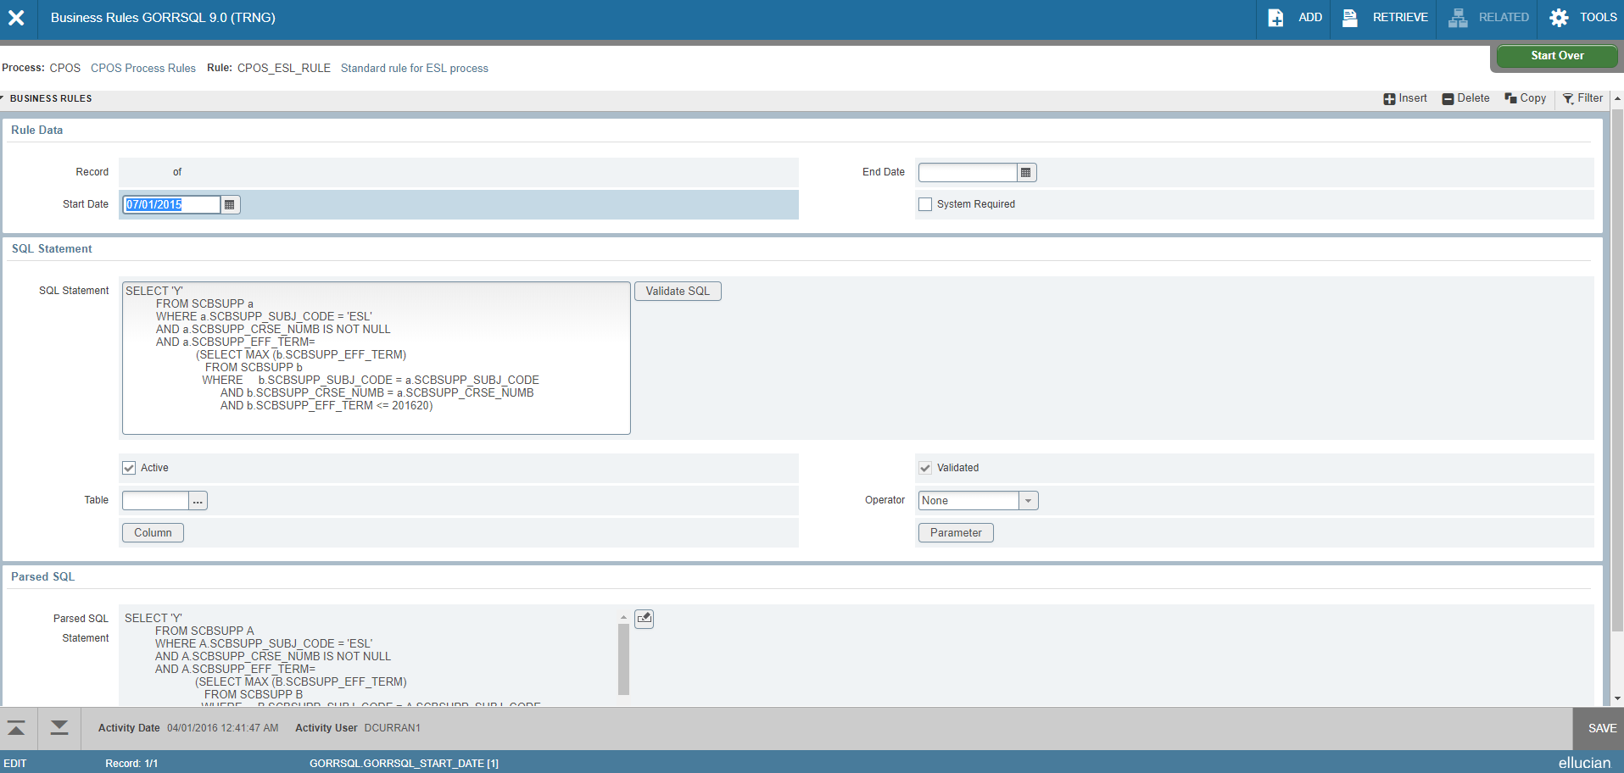

* SFACPSC- Course program of Study Control Page
  + Processing Rules Tab:
    - As appropriate, activate ESL, Remedial, and Repeat processing by checking “Yes”
    - Enable Preform in Program Processing by checking “Yes”
    - Set the Audit System to use CAPP or Degree Works
    - Enter Control Rules to be used by SFPCPOS
    - Enter Registration Terms that should have changes tracked by SFPCPOS
    - Define start and end dates for identifying registration changes for SFPCPOS

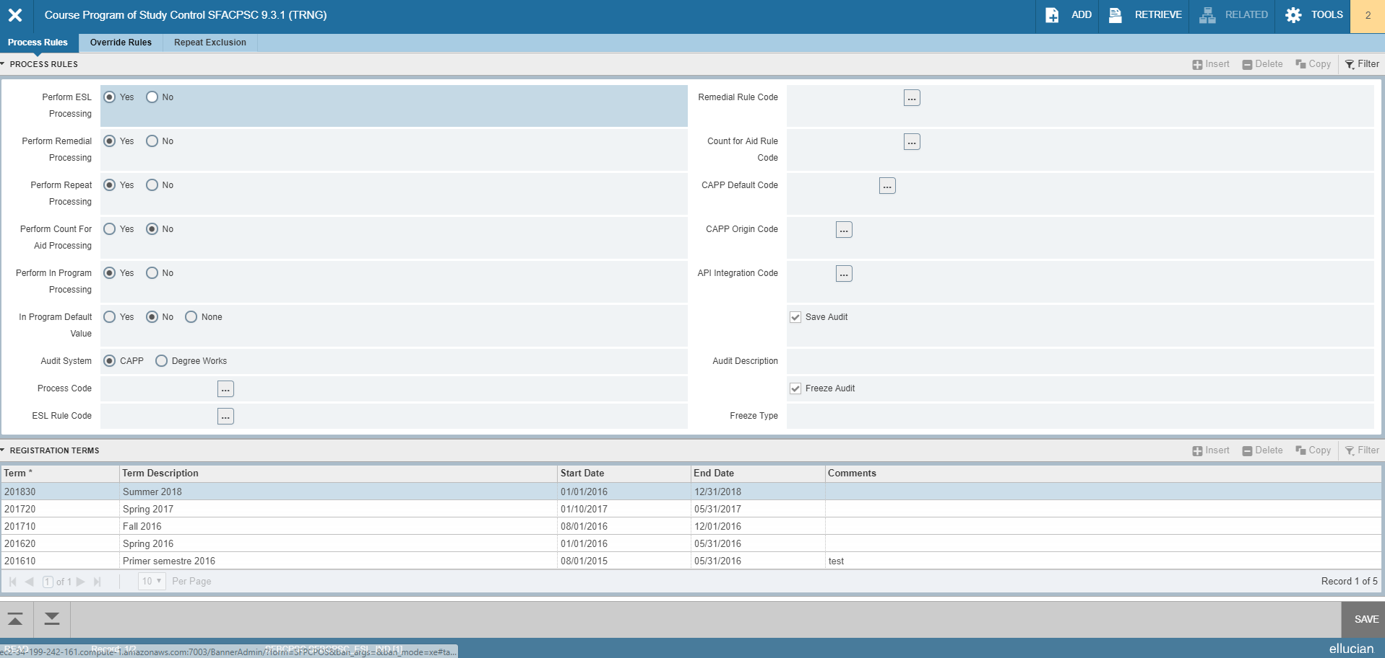

* Override Rules Tab:
  + Setup rules for courses in program overrides to override institution control rules for courses
  + Determine if courses should or should not be counted in degree audit from a specific term to and end term

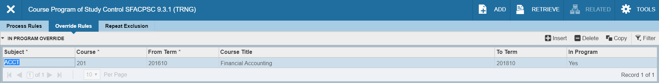

* Repeat Exclusion Tab
  + Transfer repeat exclusion courses from RORRPCX to SFACPSC to be used by SFPCPOS

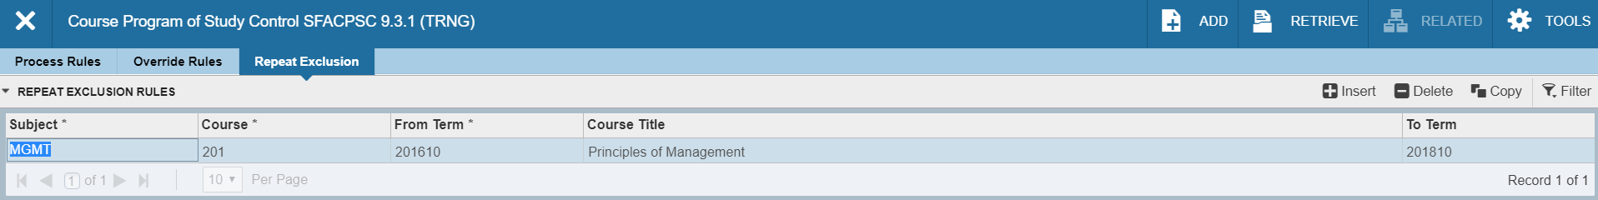

* Setup Degree Works or CAPP as applicable
* New Process:
  + SFPCPOS- Course Program of Study that populates page SFASCRE with the course audit information to be used in Financial Aid enrollment counts
* New Page:
  + SFASCRE- Student Course Evaluation Audit
* Reference Banner Student 8.9 Release Guide for additional information

# Setup- Banner Financial Aid

* RORMPRM- Miscellaneous Parameters
  + The 8.24.2 Release delivered four values that DO NOT integrate with Student Course Program of Study these values maintain current enrollment functionality
  + Four delivered ENROLLMENT_RULES Parameter Keys:
    - COURSE_IN_PROGRAM
    - ESL
    - REMEDIAL
    - REPEAT
  + Data value for these rows are ZZZZZZ
  + Source Indicator of Baseline and a System Required indicatory (current functionality) not integrate with Student Program of Study

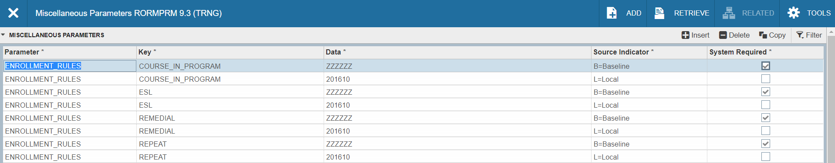

* + To Integrate with Student Course Program of study, new entries will need to be entered on RORMPRM
  + Enter local entries for new enrollment calculation
  + Preform Record Duplicate to add local Source indicator
  + Enter term code in Data column for term when new enrollment calculation should begin, the below screen shot illustrates enrollment calculation that will begin 201610 period/term. Enrollment calculation for periods/terms prior to 201610 will not use Course in Program of Study enrollment calculation
* ROAINST- Global Institution Financial Aid Options- Defaults Tab
  + Uses with Course Program of Study functionality for enrollment calculation. Determines how to handle course not in SFASCRE or is disabled.
  + Course in Program (how to handle a course when the course is not in SFASCRE)
    - Yes- check to default is included in student’s program
    - No- uncheck to default course is not included in student’s program
  + Repeat Course Checking (determine how to handle course not in SFASCRE or Disabled)
    - Yes- check to default course is considered a repeat
    - No- uncheck to default course is not considered a repeat
  + Remedial Course Checking (determine how to handle course not in SFASCRE or Disabled)
    - Yes- check to default course is considered a remedial
    - No- uncheck to default course is not considered a remedial
  + ESL Course Checking (determine how to handle course not in SFASCRE or Disabled)
    - Yes- check to default course is considered as ESL
    - No- uncheck to default course is not considered as ESL
  + Remedial No. Default- Default number of remedial hours to assign when the Remedial Course Checking is checked
  + Repeat No. Default - Default number of repeat attempts to assign when the Remedial Course Checking is checked
  + Remedial Limit- Define the default number of hours for remedial limit calculation (limits the number of remedial hours that can be included in student’s enrollment count)
  + Remedial Limit Rule Code- Define an algorithmic rule that calculates the appropriate remedial hours based on the student’s criteria.
    - Institutions have the options to default a remedial limit or create an algorithmic rule that calculates the appropriate remedial hours based on student criteria
    - Set up of Remedial Algorithmic Rule:
      * RTVALGO
      * RORALGO- Process = (DRML) default remedial limit

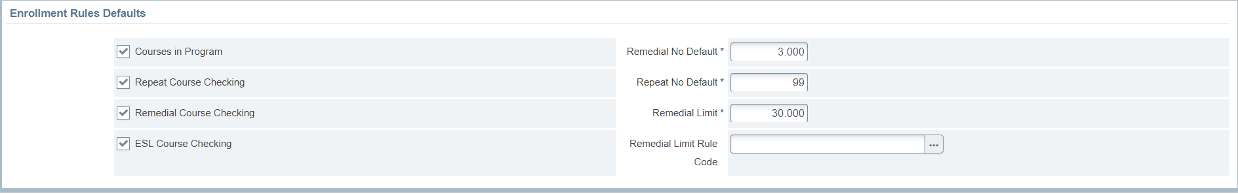

* RORENRR- Enrollment Rules
  + Exclude Remedial Courses check box is now updateable
  + Apply Remedial Limit checkbox was added
    - Works with Exclude Remedial Courses to allow remedial courses up the defined number of remedial hours
    - When the allowable remedial hours limit is reached, course hours beyond the limit are excluded from enrollment count. Only includes hours with the defined remedial limit set on ROAINST as the default number or the algorithmic rule calculation
  + Check to exclude ESL courses as appropriate
  + The Course in Program check box is now updateable- check to include hours which count in program

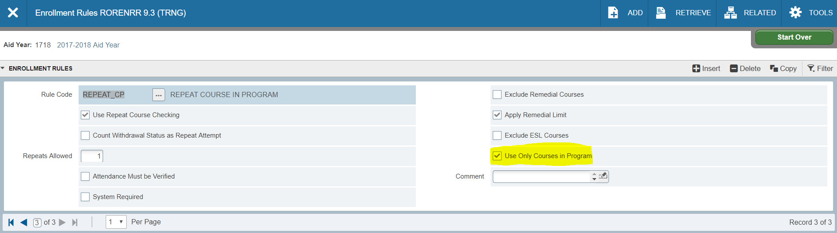

* RORRPCX- Financial Aid Repeat Course Exclusion
  + Contains list of courses excluded from repeat course enrollment calculation such as legitimate theses/dissertation or physical education courses
  + Used in current logic
  + If using Course Program of Study functionality setup SFACPSC Repeat Exclusion tab with these courses
* ROAENRL- Student Adjusted hours still sums the hours that are not excluded by the following:
  + ROAINST- excluded by level on the Exclude Course Level Tab
  + RPRAUDT- excluded by registration status or grading mode
  + ROASECT- courses excluded by term
* Reference Banner Financial Aid 8.24.2 Release Guide for additional information

# Processing

The Banner Student process SFPCPOS (Student Course Program of Study Process) determines the following eligibility criteria to be included in Enrollment Rules (RORENRR) processing:

* Course is included in student’s program as determined by CAPP, Degree Works, or institution developed evaluation
* Course is defined as ESL
* Course is defined as a repeat

The SFPCPOS process will populate the SFASCRE page.

* ROAIMMP- the SFPCPOS process can be run online for an individual student from ROAIMMP, by using the “evaluate courses in Program of Study” option. The output will go directly to the jobsub directory.

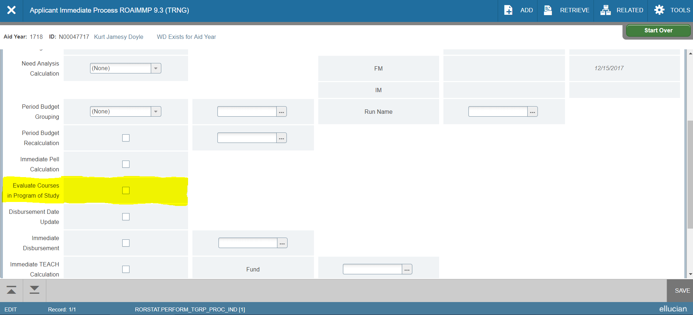

* The SFPCPOS (Student Course Program of Study Process) is designed to ran via a batch process
  + The user will need security permission class BAN_DEFAULT_M to run this process in batch or online and will also need to be in the correct group to execute the sfpcpos.shl
  + Review log and lis files for successful completion or report of errors
  + SFPCPOS job parameters:

|  |  |  |
| --- | --- | --- |
| **Number** | **Parameter** | **Description** |
| 01 | Run Mode | B- Batch  P- Population Selection (enter parameters 02-05)  S- Single Student ID (enter parameter 06) |
| 02 | Selection Application Code | FINAID (if using P Run Mode) |
| 03 | Selection Identifier | Population Selection Name (if using P Run Mode) |
| 04 | Selection Creator ID | Banner User ID that created the Population Selection (if using P Run Mode) |
| 05 | Selection User ID | Banner User ID the ran the Population Selection through GLBDATA (if using P Run Mode) |
| 06 | Student ID | Enter the Student ID (if using S Run Mode) |
| 07 | Run in Sleep/Wake Mode | N- Run Now  Y- Sleep/Wake Mode |
| 08 | Sleep Interval | Enter time in seconds to pause before resuming execution |
| 09 | Use Term as Catalog Year | N- Use Academic Year  Y- use Term Code |

* SFASCRE- Student Course Evaluation Audit Page will be populated from the SFPCPOS process

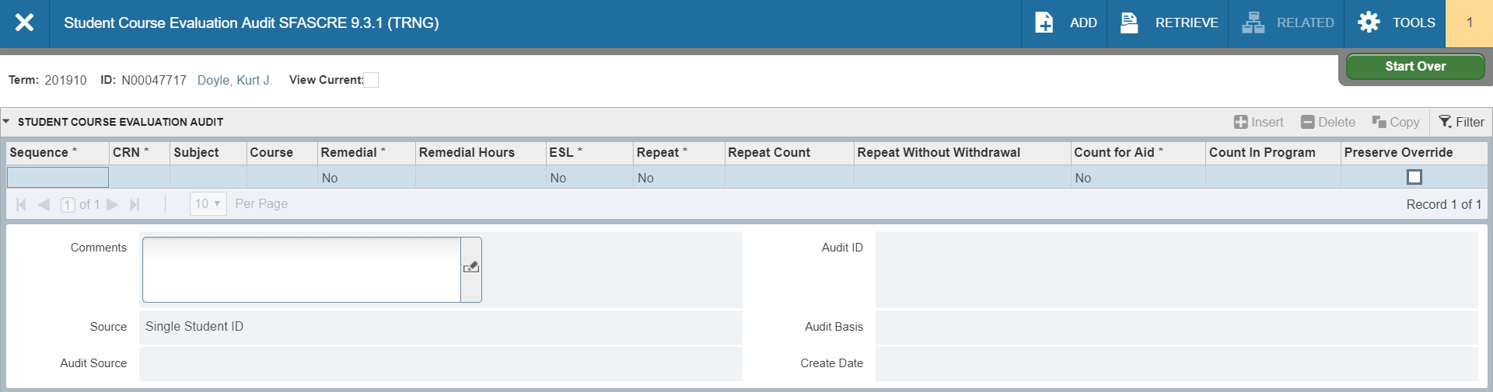

* ROAENRL- Enrollment Rules calculate enrollment totals based on:
  + Course Program of Study data in SFASCRE
  + Settings in RORENRR and ROAINST

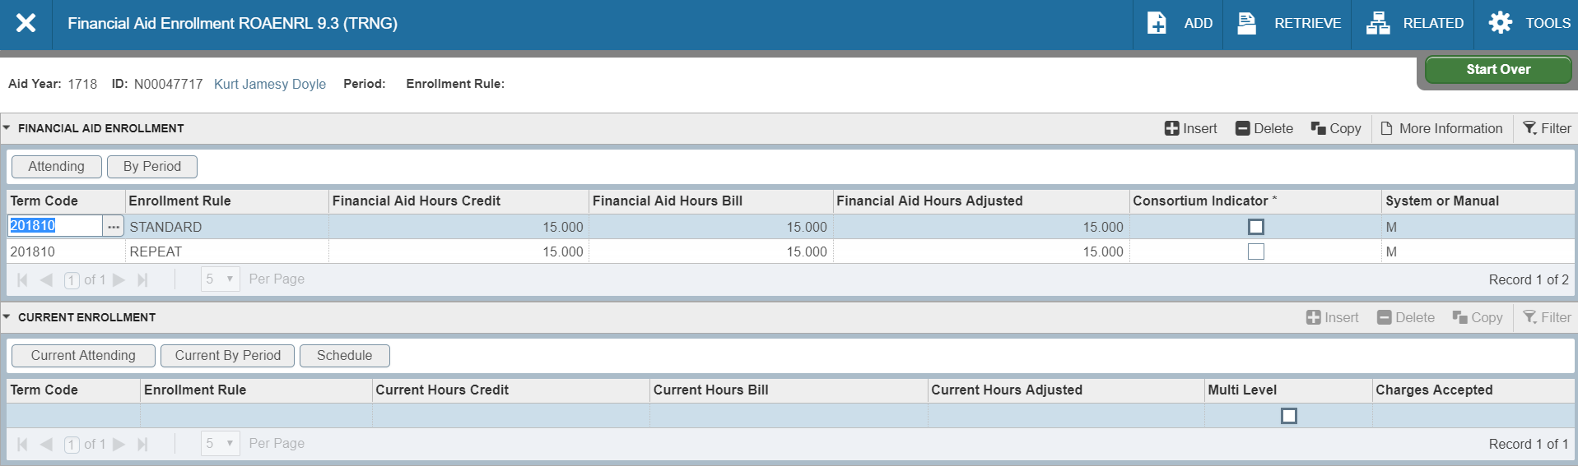

* ROAENRL- Using the Schedule button within the Current Enrollment Section, it will display the enrollment by course from SFASCRE

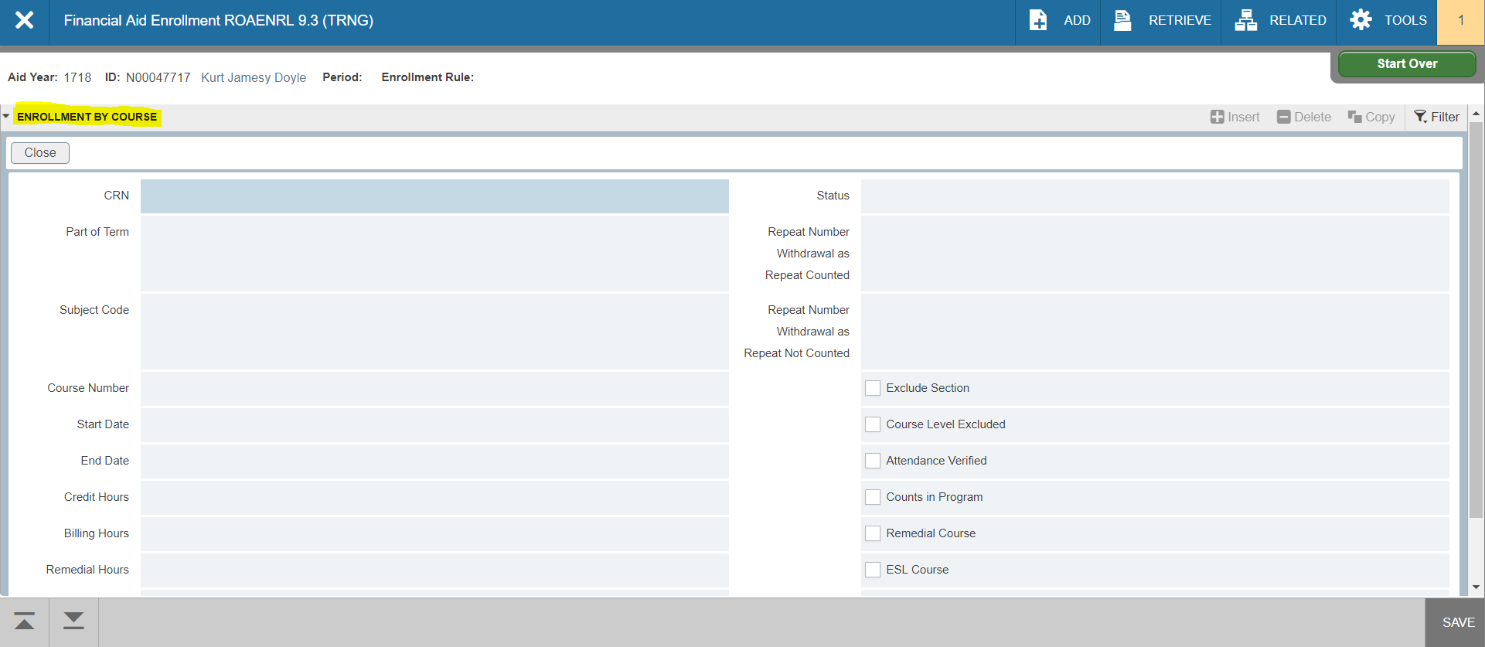

# Additional Resources

To listen to the presentations which includes setup, processing, and examples of the Course in Program of Study within Banner, please visit the Ellucian Training site, if applicable, at the following link: <https://training.ellucian.com/learn>.