**Configuring Degree Works and Banner to Use CPoS**

## Key

Items highlighted in green have not been verified. Those statements are based on my understanding of how CPoS works.

## General Info

Currently, the CPoS process does not distinguish between courses in required and non-required blocks. All courses that are used to satisfy a course requirement in either a required or non-required block will be considered in program of study. The only courses that will not be considered in program of study are courses that are courses marked as ECA-Overflow in the fallthrough section. If scribed correctly, clients who have "Fall Through Count in Overall" set to N in CFG020 DAP 14 will have all of the courses in the fall through section marked ECA-Overflow.

When you run CPoS from Banner, it runs a what-if audit in Degree Works. The API receives the input to refresh the student's data from Banner. Hence, all CPoS audits are run against the most recent student data in Banner. The last refresh date that you see on the Dashboard, however, does not reflect the date and time when the what-if audit refreshed the student's data.

When you run CPoS from Banner, you can choose to save and/or freeze the what-if used to determine which courses are in program of study. When you save the audit, Degree Works will ignore the UCX-CFG020 DAP14 What-if History Count setting. A saved, but not frozen, will be deleted as what-if audits are run from the dashboard when the DAP 14 What-if History Count setting is enforced.

Many clients run CPoS nightly. Hence, they do not want to freeze audits unless they build a process to delete frozen CPoS audits. After becoming familiar with CPoS, they may not want to save audits since they can always re-run a student and see the audit.

## Degree Works Setup Steps (From Master Article)

From: <https://ellucian.force.com/clients/articles/FAQ/How-do-I-set-up-CPoS-processing-when-using-Degree-Works>

1)  The user, **WHATIFAPI**, is delivered with Degree Works.  Verify that the **WHATIFAPI** user has the**RSWHATIF** key.  In 4.1.5, the **RSAUDIT** key is also needed. This can be verified by viewing the $ADMIN_HOME/common/SHPCFG file on your Degree Works application server or through the Shepentry java application.  If keys were added be sure to stop/start the java applications.  
  
2) Add a shpsetting for services authentication. To do that:

* Go to Shepentry in dwShell.
* Click System Settings
* Click New
* Add the following values:
  + Key = core.security.authenticationType
  + Value = SHP
  + Specification = services
* Note that SHP is case sensitive and needs to be all capitals.

3)  Verify that the **Degree Works services war file (degreeworks-services-*.war)**has been successfully deployed by entering the following:

http://yourserver:port/<services_path>/  
*For example: http://m99999.ellucian.com:7006/dwservices/*  
  
This should be returned to the screen:  
application.wadl

NOTE:  As of 4.1.6, to deploy the degreeworks-services-*.war file, SSL needs to be set up in that environment.  
  
This application supports all public Degree Works APIs. Degree Works provides several web services that provide access to several areas of articulation, audit, student and system data. These are documented in the Degree Works API section of the Ellucian XE Registry, which you should be able to access from the Ellucian Support Center.

## Degree Works Settings

**Configuration**

* If a campus is using Program as Degree (Program as Degree is set to Y in CFG020 Banner), make sure core.audit.programAsDegree is set to true.
* Verify that in CFG020 DAP14
  + "Check Elective Credits" set to Y (Important note: The qualifier, "CheckElectiveCreditsAllowed" trumps the CFG020 DAP14 setting. The two work differently. Clients should remove or comment out "CheckElectiveCreditsAllowed" qualifiers.)
  + "Apply In Progress" set to Y
  + Note: CPoS looks at in-progress coursework. The following settings potentially effect whether a current course is treated as an in-progress course.
  + "In-Progress Withdraws" set to Y. Once a student withdraws from the course, Degree Works will put the course in insufficient. Hence, the course will no longer be in program of study.
  + "Follow Gradable Indicator" If set to Y and sections marked as non-gradable are charged tuition and eligible for aid, they will not be considered in program of study since the will not be on the audit. Generally, these sections are worth 0 credits so the client will not have an issue.
* Note: the following settings could affect CPoS but are typically not issues given the typical setting values:
  + "Apply Historic Repeat" setting should not matter since CPoS has its own rules for repeat processing that is done within Banner. (not verified)
  + "Load Current Grade if Exists": If set to Y, when loaded the courses will no longer be IP and not evaluated for CPoS (not verified) If set to Y, then "Grading Period Increment" and "Grading Period Increment" have implications.
  + "Extract Midterm Grade" What are the values? Is it no longer IP?

**Permissions**

* WhATIFAPI user in Degree Works needs RSWHATIF, RSAUDIT, WIFREEZ, and ANYSTUID keys. As of DW 5.0.1 service pack 1, the user also needs NOREFER.
* Users who will be running CPoS in Banner should have permission to see and delete frozen audits. Hence, they need the keys SDWIFHIS and SDWIFDEL.

## Banner Set Up an Information

**Clients should read: Course Program of Study (CPoS) in the Banner Financial Aid Guide for more information on settings.**

1. Define the External API (the Degree Works API) on **STVREST** and **SOAREST**.

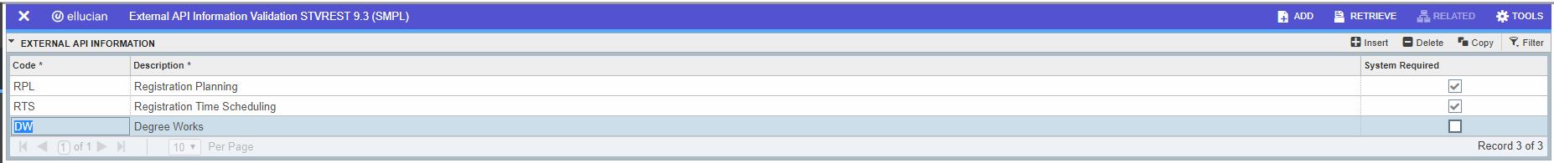



1. Start the use of CPoS on **RORMPRM** by duplicating the rule Course_in_Program. Change the data field to the first term for which you plan to run Course Program in Study using the Degree Works audits.

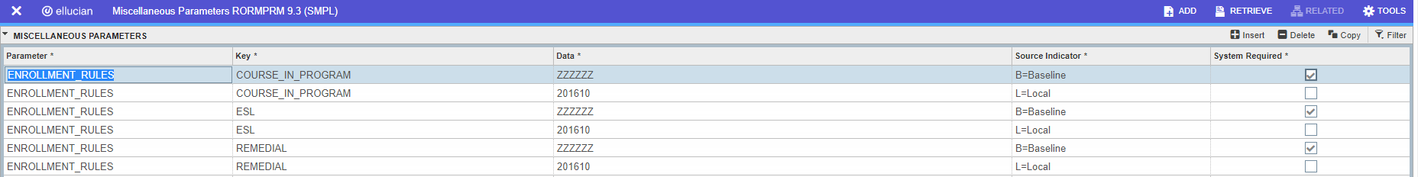

1. Set up the rules on **RORENRR** for the Aid Year. At a minimum, check "Use Only Course in Program." Choose other options as desired.

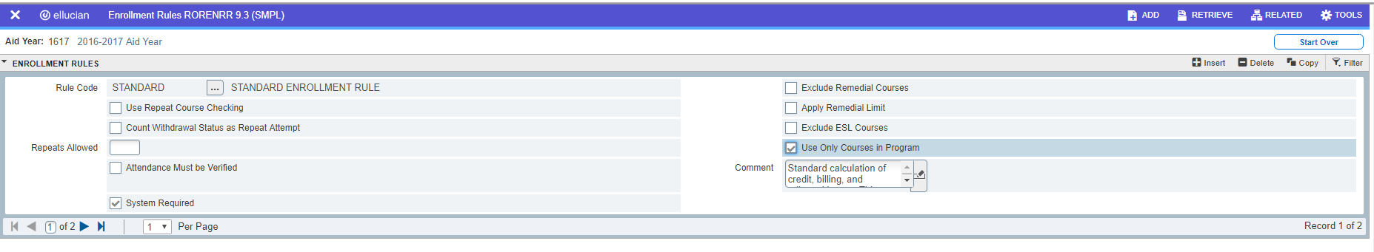

1. Choose appropriate defaults on **ROAINST** for the financial aid year. At a minimum check "Courses in Program." Choose other defaults as desired.

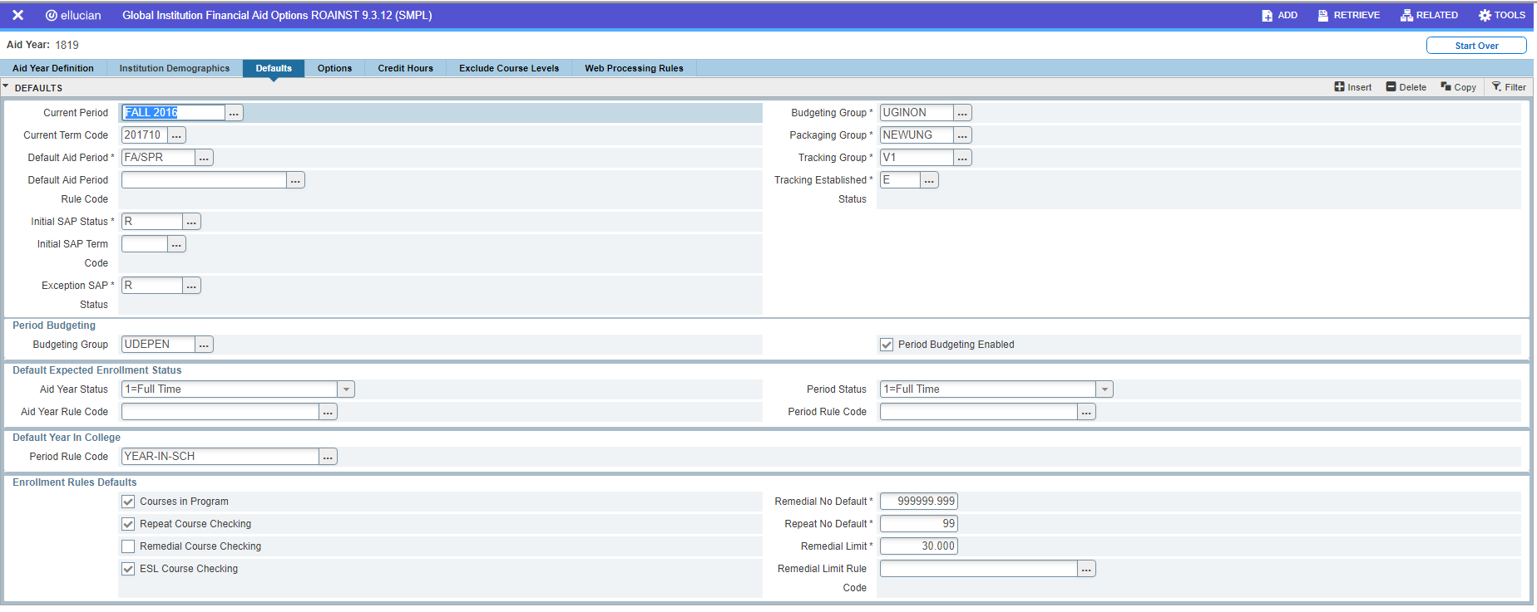

1. Set up the rules for Course Program of Study on **SFACPSC**. You need to make sure you add the appropriate registration term. Choose Degree Works as the audit system.

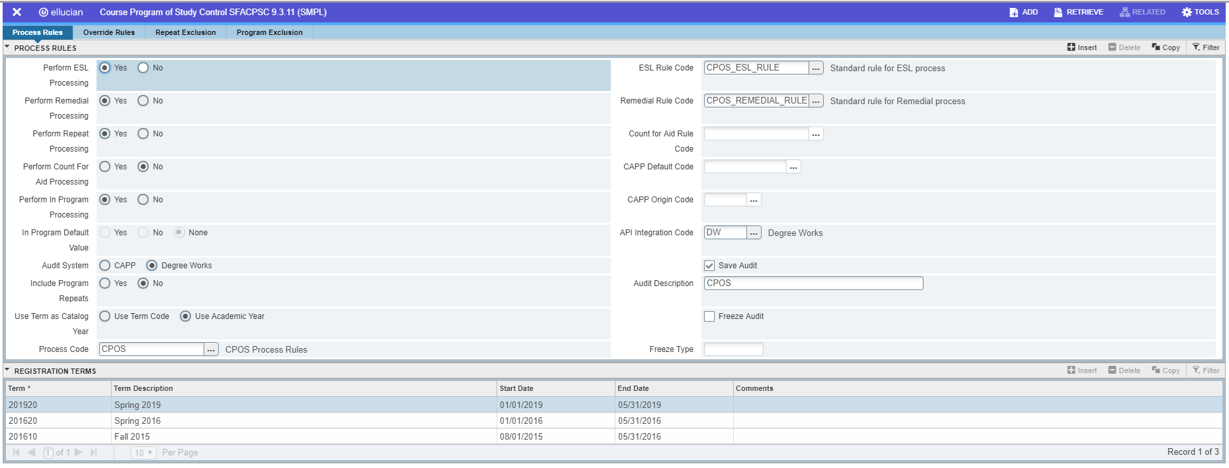

1. Notes:

* The start and end dates are not the start and end dates of the term. Instead, the start date is the date on which you want to begin CPoS processing for the term. The end term is the last date on which you want to run CPoS processing for the term.
* Campuses that have set CFG020 Banner "Use Term as Catalog Year" set to Y, should select "Use Term Code" for "Use Term as Catalog" on **SFACPSC**. Campuses that have set CFG020 Banner "Use Term as Catalog Year" set to N should select "Use Academic Year" for "Use Term Code" on **SFACPSC**.
* The API Integration code should be the value you set up in step 1.
* You have the option to save the audits used in Degree Works by choosing the save button. The save button will save the what-if audit in the Degree Works database. The UCX-CFG020 DAP14 What-if History Count setting is ignored. When additional what-if audits are run through the Dashboard, the saved audit may be deleted.
* You have the option to freeze the audit so that it will be stored in the Degree Works database and will only be deleted when you decide to delete the audit. The what-if audit history count will not determine its fate in the database. If you choose to freeze audits, add a description and provide a freeze code that is valid in UCX-AUD032. These frozen audits can be seen in Degree Works under the what-if history tab. Freezing audits can use substantial disk space since you will add an audit for every student for whom you run CPoS.
* Program can be excluded from the CPoS process by entering them on the Program Exclusion tab of **SFACPSC**. Exclusions have starting and ending terms. Hence, clients new to Degree Works can exclude students who do not have audits in Degree Works.

QUESTION: WHAT HAPPENS WHO ARE EXCLUDED? I’m waiting to hear from the Banner Financial Aid Team.

1. Run the CPoS process on **SFPCPOS** students in batch, sleep/wake or any individual student. You can also run the process for an individual student on **ROAIMMP**.

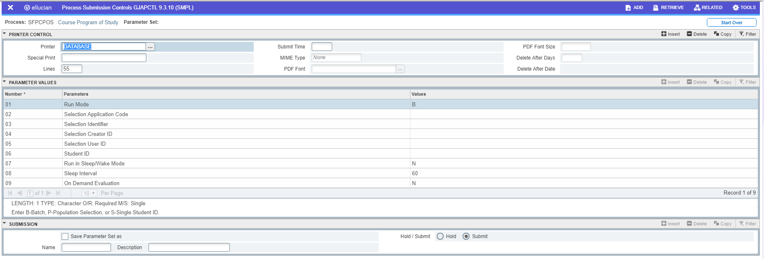

1. You can view the results in **SFASCRE**. You have the option to override the results on the form. To preserve those values from future running of CPoS, check the "preserve override" box. Note: you will see values in this table from each running of the process. Click on "View Current" to see the results from the most recent running of CPoS. The screen also tells you the audit number for the results. If you've saved or frozen the audits, you can see the audits within Degree Works. If the audit number has been removed from the Student View through localization, you can see the number on the Diagnostics Report.

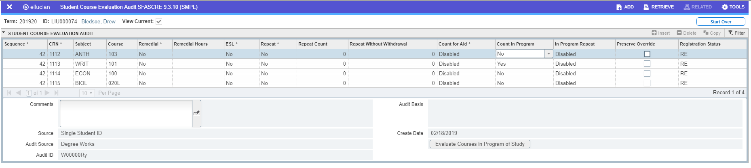

If a user has turned on sleep/wake for CPoS, they can evaluate courses in Program of Study from SFASCRE.

1. Observe the results of the enrollment rule on **ROAENRL**.

|  |  |
| --- | --- |
| RequestConfiguration.SaveAudit | Save the what-if audit to the Degree Works database or not. The UCX-CFG020 DAP14 What-if History Count setting is ignored. |

|  |  |
| --- | --- |
| RequestConfiguration.RefreshStudentData | Before running the audit, refresh from Banner or Colleague. |

|  |  |
| --- | --- |
| RequestConfiguration.SaveAudit.Freeze | Freeze the audit to the database or not. The UCX-CFG020 WEB Allow Audit Freezing setting is ignored. The user must have the WIFFREEZ key to freeze an audit. |
| RequestConfiguration.SaveAudit.Freeze.FreezeType | When freezing, a valid UCX-AUD032 freeze type must be provided. Maximum length is 6 characters. |

**Recommendation**:

Initially, set up Banner to save audits. User can then see the audit in DW in what-if history. If you do this, make sure that users who will be running CPoS in Banner have access to what-if history. Freezing audits will increase the amount of disk space used in Degree Works since you are likely to have a frozen audit each term per student. Changes to registration records can trigger running CPoS, so the number of frozen audits may be substantial. Clients should create procedures for deleting these frozen audits.

Once a client is familiar and has thoroughly tested, they do not necessarily need to freeze the audits. They can freeze an individual student although they'd need to change a setting in Banner prior to running the process.

## Interpreting the ECA calculation on the Diagnostics Report

When you tell Degree Works to calculate ECA[1], the only change you will see on the Student View as delivered is a change to the calculation used for the credits progress bar if "Fall Thru Count in Overall" is set to Y in DAP14. With ECA turned on, credits that are identified as not needed for the degree are not included in credits applied to the credits bar. Additionally, you will see the outcome of the calculation on the Diagnostics Report. In the Electives section, courses will be marked as ECA-OK and ECA-Overflow[2]:

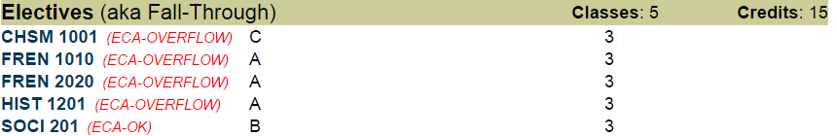

Additionally, the ECA calculation and summary will appear in the degree block:

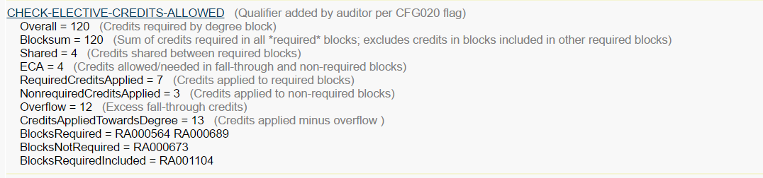

Note: Blocksum (Sum of credits in all "required" blocks, excludes credits in blocks included in other required block) is the higher of the following:

1. The sum of the credit or credit pseudo qualifiers in all blocks called in from the degree block (or starting block);
2. The sum of credits used to fulfill requirements in all blocks called in from the degree block; or
3. The credit or credit pseudo qualifier in the degree block.

Scribing determines whether a block is required or non-required[3]. If a block is optional[4], then the block is non-required. Coursework in non-required blocks will be considered in program of study, but the credits will not be counted in the ECA calculation. Hence, majors and minors should be explicitly called into the audit.

Credits are not split in calculating Elective Credits Allowed. For example, if ECA equals 10 and the student has four 3 hour classes in fallthrough, all four classes will be considered ECA-OK.

***NOTE: Currently, the Banner CPoS process will consider all courses in program regardless of whether the course is in a required block, a non-required block, or a block called into a required block if the course appears anywhere in a block called into the audit. Courses in fall through will only be counted as in program of study if the course is marked ECA-OK. The only courses that are not in program of study are courses marked ECA-Overflow.***

## Degree Works Scribe Considerations

CheckElectivesCreditsAllowed Qualifier:

Verify that the scribe is not using the CheckElectivesCreditAllowed qualifier. The ECA Calculation is different if you're using the CheckElectiveCreditsAllowed qualifier. The CheckElectiveCreditsAllowed qualifier trumps the CFG014 DA14 Check Elective Credits setting.

Credit Totals:

All blocks called in from the degree block must have credit total qualifiers. If you do not want credit totals to be evaluated, you can use credits pseudo. You cannot use classes without specifying credits. If you want total classes evaluated, you must specify classes and credits. If you use classes, you cannot use credits pseudo. If you specify credits and classes, <NEEDE> in proxy-advice will be in terms of credits. If you do not include credit totals, you'll get errors in the ECA section of the Diagnostics Report.

If you have a block (proficiency requirements) that can be satisfied with 0 credits by an exam or noncourse (see example) that has to be called in from the Degree Block, you still need a credit pseudo or you will have errors on the ECA calculation. Degree Works does not allow 0 credits pseudo. You can, however, use 0:1 credits pseudo which will make the calculations work correctly since the auditor uses the lower value when you specify credit ranges.

Sample of a Proficiency Block With no credit check and pseudo credits

BEGIN

0:1 credits pseudo #A block with 0 credits pseudo will not parse

StandAloneBlock

;

1 Group in

(1 Noncourse (WPE=Y)

Label 1 "Writing Proficiency Requirement - Met") OR

(3 Credits in ENGL 2113

Label 2 "Intermediate Composition and Grammar")

LABEL 3 "WPE or INTERMEDIATE COMPOSITION";

END.

The credits assigned to a block for the ECA calculation (used in blocksum calculation) will be the highest of 1)Minimum credits assigned to the block (If the block has a credit range, the lower value of the range will be used.) 2) The credit total of courses used to satisfy the block requirements which can exceed the credit qualifier. For example in the sample block of a Proficiency requirement, the ECA Calculation will treat the block as 0 credits if the block has not yet been completed. If the student completes the block with ENGL 213, the ECA Calculation will include 3 credits in blocksum.

Credit Ranges

Clients need to understand the consequence of using credit ranges in scribe or having credit totals on blocks that do not match the credit total of the courses that are used to satisfy the block. For example, say we have an audit that consists of the following three blocks:

|  |  |
| --- | --- |
| Block | Credit Qualifier |
| Degree | 120 Credits |
| Major | 40 Credits |
| General Education | 27:30 Credits |

If the student has not completed any courses in General Education, the student will be allowed 53 electives credits (120-40-27). If the student completes General Education using 27 credits, the student will be allowed 53 elective credits (120-40-27). If the student completes General Education using 30 credits, the student will be allowed 50 elective credits (120-40-30). Assuming no sharing, if the student has taken 50 elective credits and not completed General Education, the audit will say that one more 3 credit elective is allowed (in course program of study). That course, however, would not be allowed if the student chose to complete General Education with the options that required 30 credits. If you want to prevent this scenario and only allow the student to have 50 elective credits and you want to use credit ranges, you'd want to alter the credit qualifier in the general education block to be

If (*scenario that leads to 27 Credits GenEd*) then

27 Credits #Alternatively, 27 Credits Pseudo

Else

30 Credits #Alternatively, 30 Credits Pseudo

This solution, however, may not be practical if there are numerous scenarios that lead to the credit range.

Degree Block (Starting Block):

The degree block or starting block for the audit contains the total number of required credits. It cannot contain any course rules since courses in the starting block are not included in the required credit calculations[5]. Hence, to use ECA calculations correctly, an audit should consist of a minimum of two blocks where the actual required courses are included in the block called in from the degree or starting block. For example, a school using Program as Degree, requires 120 credits and puts all of its required courses with the exception of 9 elective credits into the degree block. The ECA calculation is

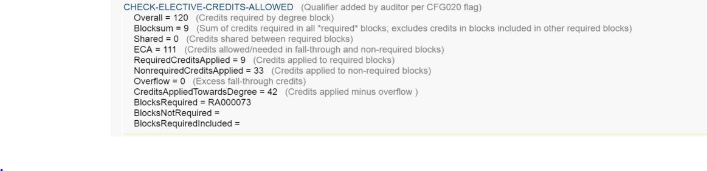

The 9 required elective credits are in block 42, but the required courses in the degree block are not included in the ECA calculation.

Prerequisites:

If prerequisites are not explicitly scribed, they will not necessarily be considered in Course Program of Study. [6] If clients do not want to use overrides in Banner, they can scribe for these courses. In scribing for these courses which should be considered part of a student's elective credits you need to get the credit totals correct and scribe using if statements. For example, a Chemistry major requires a student to complete, MATH 156 College Algebra and CHEM 100 Basic Chemistry as pre-requisites. Since students can place out of these courses, the client doesn't want to build these into the Chemistry audit. If the student doesn't place out of the course, they should be considered part of program of study.

**Sample: Assumes Major is 30 Credits not counting prerequisite courses**

## ELLUCIAN UNIVERSITY

## MAJOR=CHEM

## Chemistry Major

## 2017-9999

##

BEGIN

If (MATH 156 was passed and CHEM 100 was passed) then

30 Credits

Else if (MATH 156 was passed) then

33 Credits

Else

36 Credits

;

IF (MATH 146 was Passed or CHEM 100 was Passed) then

1 Block (OTHER=PREREQCHEM)

Label 1 "Chemistry Major Prerequisites"

End.

## Sample PreRequisite Block for CPoS

## OTHER=PREREQCHEM

## Chemistry Major Prerequisites

## 2017-9999

##

BEGIN

## No credit is needed since called into Major block which isn't the

## starting block

StandAloneBlock #To allow courses to be used elsewhere on audit

#Sharing calculation will adjust ECA calculation

;

If (MATH 156 was passed) then

3 Credits in MATH 156

Label 1 "College Algebra"

If (CHEM 100 was passed) then

3 Credits in CHEM 100

Label 2 "Basic Chemistry"

END.

If "Fall Thru Counts in Overall" is set to N in DAP14:

Typically, when using ECA, you'd set "Fall Thru Counts in Overall" to Y so that Degree Works calculates the number of elective credits allowed for the degree. If you set "Fall Thru Counts in Overall" to N, you need to use sharing to help determine the number of elective credits allowed. If minors and second majors can be used as electives, you need to make sure that elective blocks allow saving with the optional minors and majors. You can exclude courses from the primary major, by setting up sharing for the second majors and Minors (Sharewith (Major=2nd).

## Business Practices that influence CPoS

Clients need to think about these business practices since they all can lead to courses in the fall through section of the audit that actually belong on course requirements. By holding courses in fall through that belong on other requirements, the courses are incorrectly identified as electives potentially reducing the number of electives allowed.

Exception Processing:

If a client waits to process exceptions courses that will be used to satisfy course requirements, those courses may be counted as electives. Hence, a legitimate elective may be marked as ECA-Overflow.

*Force Complete*:

If a client issues a force complete exception to a course requirement and the audit uses pseudo credits, the client must also use and adjust the limit to change the associated pseudo credits qualifier. If the change the limit is not added, the ECA calculation will not reflect that the student needs an additional elective credit to make up the credits waived.

Advisor_Approved or Pseudo@ credits

Requirements that will be identified on an individual basis using exception processing also lead to courses that will fall into fall through before the exceptions are entered. Hence, a legitimate elective may be marked as ECA-Overflow until the exceptions are entered.

Undecided/Undeclared or Missing Minors, Majors, and Concentrations: When a student has not declared part of his or her program, the student's curriculum record does not include a major, minor, or concentration. For ECA calculations to work correctly for these students, the audit must include the total number of required credits with no course rules in the starting block. The student will likely be allowed more ECA-OK credits until the student has declared all the elements of his or her program of study. The calculations should be correct because the audit is less specific than it will be after the student declares all the elements of his or her program of study. Clients should be made aware of how these students will be treated in these ECA calculations to ensure that the calculations are consistent with their financial aid policies or athletic eligibility rules. Typically, for beginning students, undeclared students do not present issues since they haven't exceeded their elective credits. If students become undeclared later in their careers or enter with substantial transfer credit, they may have already exceeded elective credits allowed. Their audits, however, could indicate a false number of elective credits allowed since their program is not on their audit.

## How to handle when you have an 'optional' block such as a GPA or Honors calculation?

Some clients include blocks that are not really degree requirements. Examples are blocks used to calculate major GPAs that include all courses that could be used to satisfy major requirements; evaluate honor requirements; and list all upper division coursework. If scribed normally, the courses used in these blocks will be considered in program of study even though the student could receive the degree without some of these courses.

Option 1 (Requires no localizations)

Since CPoS uses what-if audits, clients can keep these ‘optional’ requirement off of what-if audits by using if statements based on auditaction. For example, if a client has an honors block that should not be considered for CPoS audits, they could scribe:

If (Attribute=Honors and AuditAction=Whatif) then

1 Block (Other=Honors)

Label Honors “Honors Requirements”

The advantage of this option is that it doesn’t require any localization. The disadvantage is that the honors block will no longer appear on what-if audits run from the Dashboard or Gateway.

Option 2 (Requires modification of a script)

The logic of this approach is to alter the script for the whatifapi so that it always passes a curriculum goal that can be used in if statements.

Step 1: Add a goal to Surecode. You can use a major, minor, liberal learning, or specialization.

Step 2: For 5.0.0+, in Composer, edit the “APIWHATIF” shpscript to include the below (or whatever values you want to pass only to the what-if API):

<$ILMASK SERVICE=RSWHATIF>

<Report>

<$ILMASK SERVICE=WIFFREEZ>     === is allowed to freeze; pass along freeze type

<$ILSERVER SERVER=DAP09 SERVICE=RSWHATIF

    NVP=ACTION=APIWHATIF**&GOALCODE="MINOR"&GOALVALUE="CPOS"&GOALCATYR=""**

    NVP=AUDITTYPE=AA

    NVP=REPORT=DUMMY

>

</$ILMASK>

<$ILMASK Not SERVICE=WIFFREEZ>  === not allowed to freeze so send in a blank freeze type

<$ILSERVER SERVER=DAP09 SERVICE=RSWHATIF

    NVP=ACTION=APIWHATIF**&GOALCODE="MINOR"&GOALVALUE="CPOS"&GOALCATYR=""**

    NVP=AUDITTYPE=AA

    NVP=REPORT=DUMMY

    NVP=FREEZETYPE=

>

</$ILMASK>

</Report>

</$ILMASK>

<$ILENVMASK DWDEBUG=1>

<!--

 Copyright 1995-2012 Ellucian Company L.P. and its affiliates.

 $Id: //Tuxedo/RELEASE/Product/server/shpscripts/APIWHATIF#1 $ -->

</$ILENVMASK>

For 4.1.6 and previous, in local/shpscripts, edit the “APIWHATIF” shpscript in the same fashion. Do a “webrestart”.

With this change, when a whatif Audit is run through the API, the student will have a goal detail of MINOR=CPOS.

Using the modification to the shpscript, a client can easily keep items off CPoS audits and include specific items on CPoS audits. To keep a requirement on an academic audit and a what-if audit run from the Dashboard/Gateway, but exclude it from the CPoS audit (an audit through the what-if api), use

If (Minor <> CPOS and Attribute=Honors) then

1 Block (Other=Honors)

Label 1 “Honors Requirements”

To keep a requirement off of an academic audit and a what-if audit run from the Dashboard/Gateway, but exclude it from the CPoS audit (an audit run through the whatifapi), use

If (Minor = CPOS) then

36 credits pseudo

Else

12 Classes

Note: users will see 12 credits on the academic audit or what-if audit run through the Dashboard/Gateway and the ECA calculation will contain errors. The ECA will be correct on the what-if audit run through the API used by CPoS.)

## Known Issues and Potential Issues

College as a Secondary Tag CR-000155108

Review scribe to see if college is used as a secondary tag. Currently, CPoS will not pass a secondary tag for college to Degree Works. Consequently, the what-if audit will not be correct. The problem is a known bug but a solution has not yet been provided. If possible, alter the scribe to use other secondary tags to find the correct scribe blocks. If college is essential, you have to create a custom variable (BAN080) to capture college and use the custom variable in if statements to sort out the degree requirements by college.

Mix and Match catalogs.

CPoS will not work correctly if a client allows a student to mix and match catalogs. As a what-if audit, the audit will be based on one catalog. The catalog will be the catalog associated with the student’s degree.

Save Descriptions:

Users cannot use ampersands in the descriptions for saved or frozen audits. (CR-000156063)

Refresh Issue (CR-00150384)

The CPoS process refreshes the student’s data from Banner but if the data has changed, the process does not run a new academic audit. If the student data has changed and is refreshed, the rad_*_hsh tables are updated so that when the nightly Banner extract processes, the student does not get recognized with data changed and a new Academic Audit is not processed. If running the CPoS nightly, CPoS should be run after the nightly student extract has been run. That way, the audits will reflect data changes.

Credits Applied and Still Needed in Degree Block

The credits used in still needed calculations on proxy-advice and credits applied that appear on the degree block do not consider the ECA calculation. Credits applied on the audit will not match credits applied towards degree in the ECA calculation. Credits applied will include ECA-Overflow credits. Clients can localize the audit to use “credits applied toward the degree.”

## Open Questions:

What happens if a course is withdrawn for current term? It should no longer be included in program of study.

What if a course is graded, but not rolled to academic history?

How does the auditor decide which classes are ECA-OK and ECA-Overflow? (See thread 61609 on eCommunities) Apparently, courses required for min header qualifiers are not considered such as minresidency. So do we recommend that a client, list all the courses instead? Standalone block? Issue will be sharing limits. Would likely apply to minCredits as well.

What happens if a client uses midterm grades on audits? CPoS may work just fine since the courses have not been rolled to academic history. A client should test thoroughly. Courses with midterm grades of F are likely to no longer be in program of study.

What happens if a client uses spmaxcredits?

**Configuration Values for the Whatif API**

* RefreshStudentData = null
* IncludeInProgressClasses = true
* IncludePreregisteredClasses = true
* IncludeInternalNotes = false
* KeepCurriculum = false
* SaveAudit = (based on setting on SFACPSC)
* Description = (based on setting on SFACPSC)
* Freeze = (based on setting on SFACPSC)
* FreezeType = (based on setting on SFACPSC)

**Student Specific Values:**

**Person**

* PersonIDCode: (SPRIDEN_ID)

**Academic Program**

* School: school
* Degree: (SOVLCUR_DEGC_CODE+SOVLCUR_LEVL_CODE) if non-PAD
* Program: (SOVLCUR_PROGRAM+SOVLCUR_DEGC_CODE+SOVLCUR_LEVL_CODE) if PAD
* Catalog Year: catalogYear (SOVLCUR_TERM_CODE_CTLG) or (STVTERM_ACYR_CODE)

**Goals**

* goalMajors = all major codes tied to the curriculum program being sent
* goalMinors = all minor codes tied to the curriculum program being sent
* goalConcentration = all concentration codes tied to the curriculum program being sent
* Option, Certificate & Certification are also sent. Option maps to the LIBL block type and Certificate/Certification map to SPEC block type.

Banner Team recommended settings

Note: No mix and match catalogs?

* BANNER
  + Program as Degree (Y/N)
  + Grading Period Increment (impacts what is considered “in-progress”)
  + Grading Period Length (impacts what is considered “in-progress”)
* DAP14
  + Audit History count (set to 03) [Makes no Sense[
  + Apply In-Progress (set to Y)
  + In-progress vs. Completed (set to N)
  + Fallthrough counts in Overall (set to N) [Why? Not necessary if scribed correctly
  + What-if History Count (set to 05) non-frozen [No required makes no sense, doesn't use this value]
  + Check Elective Credits Allowed (set to Y)

1. I am also assuming that "Fall Thru Count in Overall" is set to Y in DAP14.
2. The AuditHD.xsl file delivered with DW 4.1.5 and 4.1.6 does not show the ECA calculation on the Fall-Through Courses in the Diagnostic report. Clients should request the correct AuditHD.xsl file from the action line.
3. The way majors and minors are pulled into the audit will determine whether a major or minor block is required or non-required. If there is no major or minor call, then all majors and minors will be non-required. If the starting block (typically, the degree block) contains a rule of "1 BlockType(Major)", then the first major will be required and all other majors will be non-required blocks. Any block called in from a non-required block will be considered non-required blocks. If you want the majors to be required, you must explicitly call in the correct number of majors. For example, if a student is a double major and the starting block contains a rule of "2 BlockType(Major)", then both majors will be required and all courses in the major block (or called in from the major block) will be considered courses in the student's program of study. The ECA summary shows you which blocks are required. Similar logic applies to minors and concentrations.
4. A block may be optional because it requires 0 credits in the header or because the block has an optional header qualifier.
5. If the audit consists only of a Degree Block and Fallthru does not count in overall totals, Course Program of Study will work properly if all of the required courses are listed in the Degree Block. If the client ever deviates from the structure, however, the ECA calculations will be wrong. Wrong: only works if ECA is correct value
6. Clients do not need to worry about remedial course work prerequisites since Course Program of Study in Banner handles remedial coursework.