U.S. EPA My Environment Site
http://www.epa.gov/myenvironment/

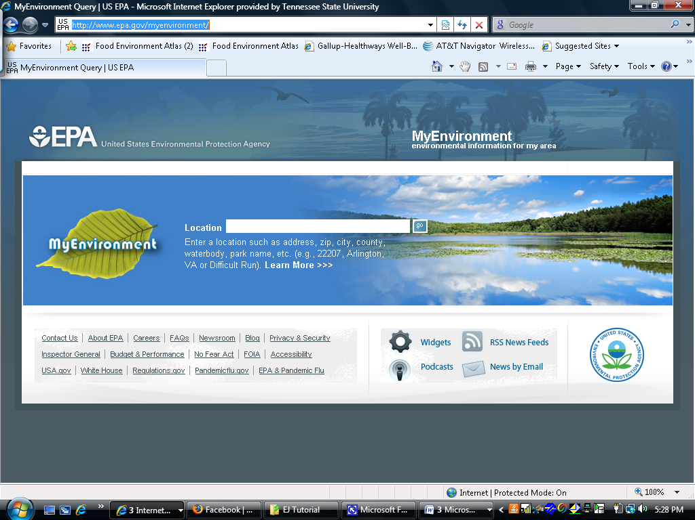

This website is important because it allows an individual to actually see the numbers that are related to particular issues. This website also allows for people to have visuals to pinpoint the areas of concern. Another key aspect of this website is the human health section; this section is rare for environmental sites because it shows the outcome of exposures to certain pollutants. this website is very useful because trends in the local environment can be tracked, and the data is easy to access as well as understand.

This website has a lot of important information about the local environment which includes:
- Air Quality-
  - information on the ozone conditions,
  - the pollutants in the air,
  - the UV index rates,
  - the radon rates.
- Water Quality-
  - information on the water conditions within the selected area,
  - including the drinking water source and statuses of the water,
  - the water quality monitoring activities,
  - the watersheds within the local area.
- Land Quality-
  - information regarding superfund sites,
  - brownfield sites,
  - hazardous wastes sites
  - clean up efforts.
- Ecological Conditions-
  - information on wildlife in the local area, but only if there is data to support the research.
- Human Health Issues-
  - information regarding some side effects due to exposure of particular pollutants,
  - information about cancer risks, mortality rates, and low birth rates
  - data presented on maps to view or for comparisons.

HOME

