Environmental Defense Fund Scorecard Website
http://www.scorecard.org/
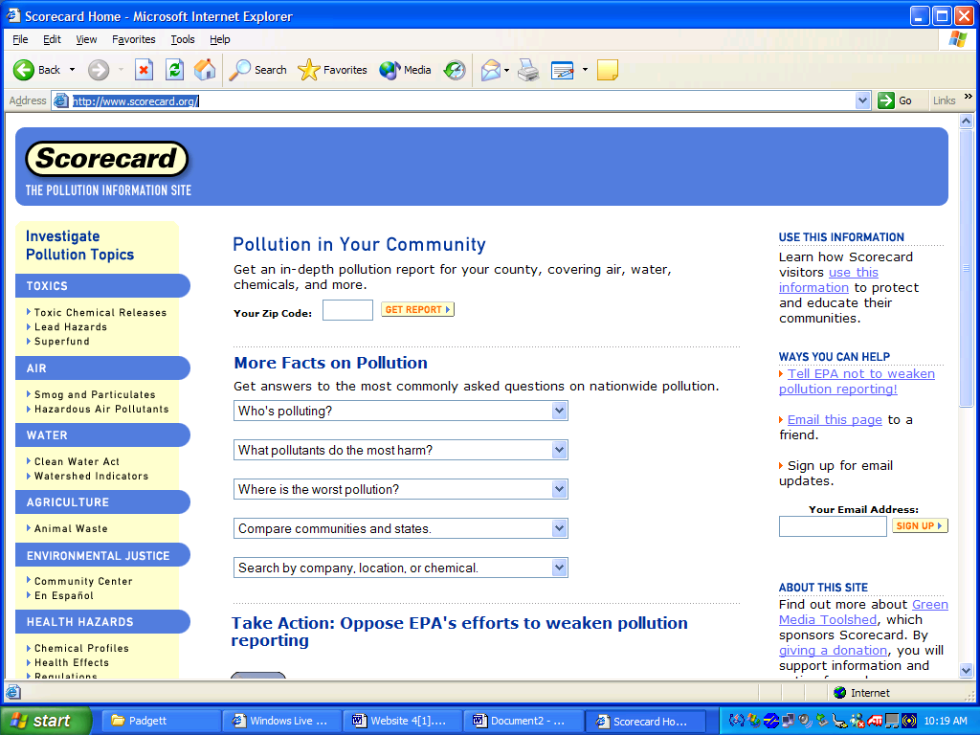
This is a pollution information website that is geared towards helping individuals investigate pollution within their communities; the purpose of this site is to help people protect as well as educate the local community on the hazards of pollution. This website lists the top 100 states ranked as the most polluted states. This website gives information on the type of toxins being released in the air, as well as the amount. Most importantly, the Score card website gives accurate information on how certain pollutants affect the human body. The site gives the amount of pollutants needed to cause a “recognized” side effect. The website connects the pollutants and human health effects to show the community of the effects of harmful pollution.

This website is useful for environmental research because of the information that is provided, such as:
- Information on pollution from various aspects such as toxins, air, water, and agriculture.
- The exact locations of waste facility plants in a specific area, as well as the exact amount of pollution produced by the plant each year.
- Information about the hazardous materials/ or toxins that are creating the most pollution in a specific community.
- Information regarding the health hazards which are a direct effect of pollution.
- Information on the “recognized” side effects of a particular toxin, and the amounts that is harmful to the human body.

HOME

