U.S. EPA
Toxic Chemical Release Inventory (TRI) Explorer
http://www.epa.gov/triexplorer/

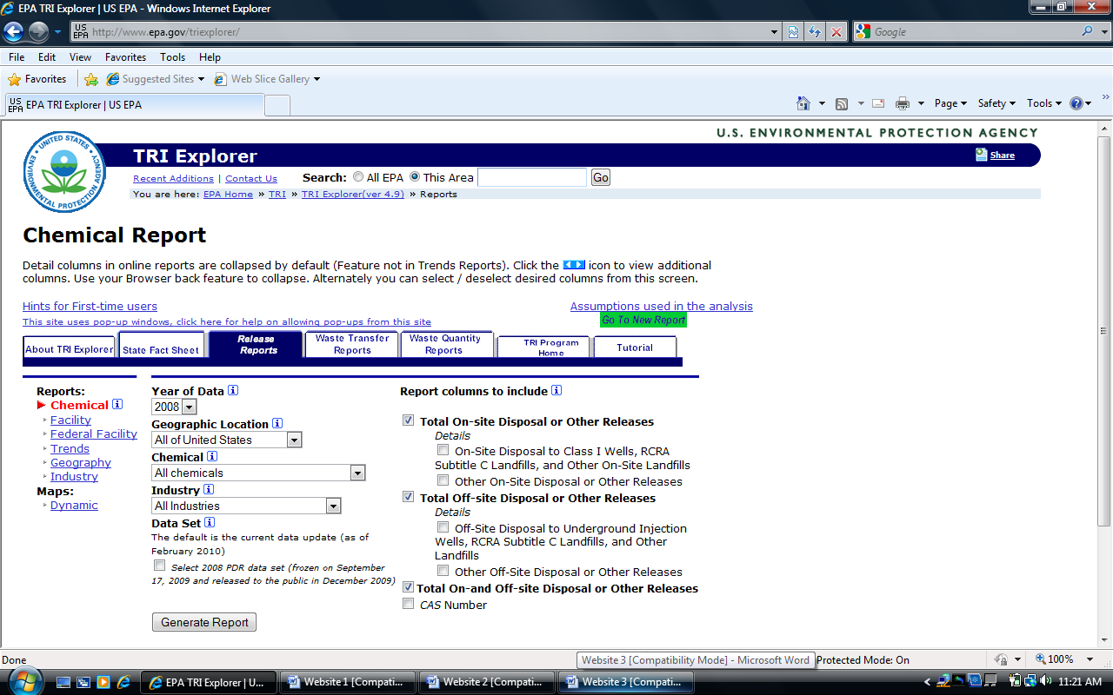
The TRI Explorer webpage is based on the Toxics Release Inventory Program (TRI). This web page gives specific information about the toxins that are in a specific area. The website provides data on information such as waste facilities, chemical disposal, and also hazardous exposure information. The webpage gives reports of waste management of federal agencies, such as the U.S. Department of Defense, and the U.S. Department of Agriculture. The webpage offers other important information such as waste transport reports as well.

This website is useful for environmental research because of the information that is provided, such as:
- State Fact Sheets-
  - information includes reported disposal of waste management facilities, both on and off site disposal amounts (in pounds), recycled products, and landfill information.
- Waste transport reports-
  - information regarding the type of waste or chemicals transported within a particular state,
    - the amount of transported material, and
    - the facility the material was sent to within the state.
- Waste quantity reports-
  - data such as recycling amounts both on and off site facilities,
  - energy recovered and treated waste for both on and off site facilities,
  - the total amounts of waste sent to off- site disposal facilities such as injection wells, and landfills.

HOME

