  College of Agriculture, Human & Natural Sciences  Cooperative Extension Program |  | Cultural & Biological Control of Southern Blight in Floral Hemp  Dr. Emmanuel Omondi Industrial Hemp Extension Specialist Dr. Margaret Mmbaga, Professor, Plant Pathology,  Dr. Anand Kumar, Graduate Research Assistant, Sai Suvidh Maddela, Graduate Research Assistant,  Mustapha Olawuni, Graduate Research Assistant, Dr. Lukas Mackasmiel, Research Associate Department of Agricultural Sciences & Engineering Tennessee State University, Nashville TN

Introduction

Southern blight, caused by Sclerotium rolfsii, is a destructive soil-borne disease affecting industrial hemp and numerous other crops in the southern United States. The pathogen thrives in warm, humid environments, spreads rapidly, and can persist in soil for many years through hardened survival structures called sclerotia. A key feature of the disease is its ability to form dense mats of white fungal growth around the base of the stem. This leads to girdling at the soil line (removal of bark around the base of the stem), which cuts off the flow of water and nutrients from the plant roots to the shoots. Once girdled, the plant can no longer transport water or nutrients, and this always results in rapid wilting, collapse, and mortality.

Because legally approved fungicide options for hemp are limited and label specific, growers should prioritize cultural and biological strategies, and, where permitted, integrate labeled fungicides within an integrated pest management (IPM) program. Always follow product labels and state regulations.

Symptoms of Southern Blight

- Initial yellowing of leaves

- White, fan-shaped mycelial colonies near the plant crown (Fig. 1)

- Mustard seed-like sclerotia forming in the topsoil and on infected tissue

- Girdling of the stem at the soil line, blocking nutrient and water movement and resulting in plant death

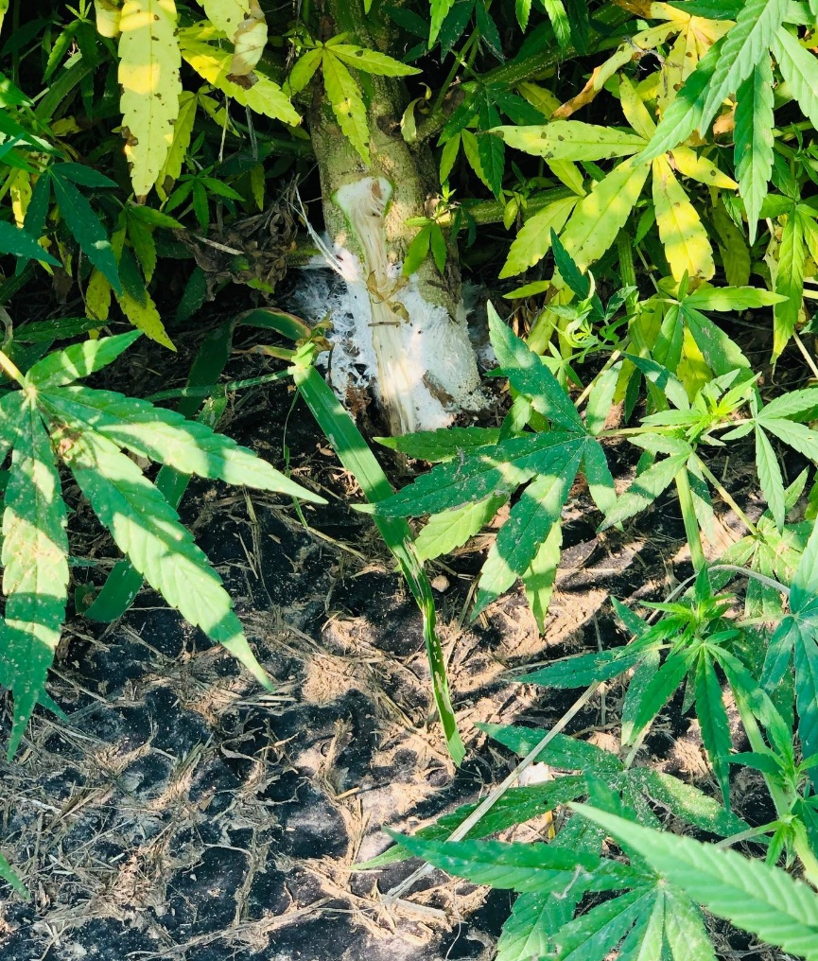
- Wilting, browning, and total collapse of the plant (Fig. 2)

Fig.1: Floral hemp crown with Southern Blight infection showing white mycelium

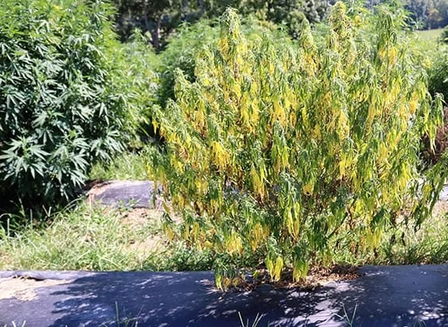
Fig. 2: Southern Blight symptoms in hemp showing sudden wilt (Louisiana State University Extension)

Economic Significance

Because fungicide options for hemp are limited and label specific, an integrated management approach is necessary. Southern blight can cause severe stand losses, reducing both yield and profitability. Field sanitation, crop rotation, biological amendments, and soil health management are critical to reduce pathogen spread and impact.

Cultural Control Methods

- Soil Solarization
  - Cover wet soil with clear polyethylene plastic during hot summer months.
  - Kills sclerotia near the soil surface, cost-prohibitive for large fields.

- Deep Plowing*
  - Bury sclerotia deeper than 8–12 inches to prevent their survival.
  - Effective initially, requires repetition over multiple years.
*Deep plowing may not be an option under reduced till or no-till practice

- Soil Amendments
  - Lime or calcium-based fertilizers maintain soil pH around 6.5, slowing fungal growth.
  - Organic amendments such as compost, straw, neem cake, and pine bark improve soil health and reduce disease incidence.

- Mulching
  - Mulches act as a physical barrier, reducing soil-to-plant contact and pathogen spread.
  - Straw mulches provide cooling and moisture retention, especially effective in hot southeastern conditions.
  - Black plastic mulch, while effective in cooler climates, can exacerbate southern blight in hot and humid regions like the Southeast by creating favorable conditions for fungal growth at the crown.
  - White or reflective plastic mulches may offer potential benefits in these climates, but their effectiveness against S. rolfsii in hemp has not yet been fully established.

- Soil Fumigation
  - May be suitable for large-scale farmers, can eliminate beneficial microbes.
  - Integrate with soil health management practices, check hemp label and state restrictions.

- Crop Rotation
  - Rotate hemp with grass crops and cover crops such as corn, wheat, cereal rye, triticale, and sorghum–sudangrass, which are less susceptible to southern blight.
  - Many vegetable and legume crops (e.g., tomato, peanut, pepper, soybean) are highly susceptible and can increase disease pressure. These crops should be included in rotations with caution and balanced with resistant grasses or non-host crops to avoid pathogen buildup.
  - Longer, diversified rotations that emphasize grasses and reduce back-to-back susceptible crops provide the best disease suppression.
Biological Control Options

- Trichoderma spp.
  - Beneficial fungi that colonize roots and soil, outcompete S. rolfsii, and produce antifungal compounds.
  - Available as soil drenches or seed coatings.

- Bacillus spp. (e.g., B. subtilis, B. amyloliquefaciens)
  - Bacteria that produce antibiotics and enzymes, suppressing S. rolfsii.
  - Applied as root dips, soil drenches, or foliar sprays.

- Coniothyrium minitans
  - Mycoparasite that targets sclerotia of soil-borne pathogens, reducing long-term survival.

- Organic amendments enriched with biocontrols
  - Compost teas and biochar inoculated with beneficial microbes enhance biological suppression while improving soil health.

- Mycorrhizal fungi
  - Improve plant vigor and nutrient uptake, increasing tolerance to soil-borne pathogens.

Note: Use only products labeled for hemp in your state, follow all label directions, and consult state regulators as labels and approvals may change.

Current Research at TSU
Tennessee State University is evaluating integrated cultural and biological strategies, including the use of Trichoderma-based products and organic soil amendments, to manage southern blight in floral hemp. Early results indicate that combining mulching, organic amendments, and biological products provides the most consistent reduction in disease incidence.

For More Information
- Tennessee State University Hemp Research – www.tnstate.edu/hemp
- Tennessee State University Hemp Research – proquest.com/docview/2917404534
- Tennessee State University – researchgate.net/publication/382756830
- University of Tennessee Hemp Program – hemp.tennessee.edu
- University of Tennessee Extension (W 916: Hemp Disease and Pest Management) – tiny.utk.edu/W916
- LSU AgCenter — Southern Blight of Industrial Hemp – lsuagcenter.com
- Kentucky Pest News — Southern Blight of Hemp – kentuckypestnews.wordpress.com

Support for this publication was provided by USDA-National Institute of Food and Agriculture through a Capacity Building Grant.
Dean - Dr. Chandra Reddy, Associate Dean for Extension - Dr. Latif Lighari
Tennessee State University is an EEO employer

Contact:
Dr. Emmanuel Omondi
Agronomist and Industrial Hemp Extension Specialist
Email: eomondi@tnstate.edu | Phone: (615) 963-5830

