  College of Agriculture, Human & Natural Sciences  Cooperative Extension Program | Industrial Hemp & Hempcrete Construction: Expanding Market Opportunities through Fiber Hemp  By Dr. Emmanuel Omondi and Anand Kumar Department of Agricultural Sciences & Engineering Tennessee State University, Nashville TN

Overview
Industrial hemp is a versatile crop that can boost farm profitability, clean soils, and supply raw materials for growing markets. Fiber hemp, in particular, is gaining momentum through applications like hempcrete; a safe, fire-resistant, and carbon-storing building material. By advancing fiber hemp research and construction uses, Tennessee State University is helping farmers, communities, and industries unlock new opportunities for sustainable growth.

Industrial Hemp
Industrial hemp (Cannabis sativa L.) is cultivated in three primary categories: floral hemp, grown mainly for cannabinoids such as CBD; grain or seed hemp, used for food, feed, and oil products; and fiber hemp, valued for its stalks that yield both long bast fibers (the strong, outer layer used in textiles, rope, and composites) and woody hurds (the inner, woody core of the stalk, also called shivs, used in products like hempcrete). While floral hemp markets have proven volatile and grain hemp is still developing in the U.S., fiber hemp is rapidly gaining attention for its broad industrial applications and scalable supply chains.

Fiber hemp not only creates new product markets but also fits well into profitable crop rotations. It grows quickly, competes strongly with weeds, and leaves soil in better condition for subsequent crops. Hemp’s unique phytoremediation capacity (special ability to pull contaminants from the soil through its deep root system) allows it to absorb heavy metals, pesticides, and other contaminants, making it a promising tool for addressing agricultural runoff and protecting water quality.

Industrial Application of Fiber Hemp
- Textiles & Paper – strong, renewable fibers for fabrics, ropes, and biodegradable packaging.

- Construction Materials – hempcrete (Fig. 1), insulation, and bio-based composites.

- Automotive & Biocomposites – lightweight molded parts and panels.

- Environmental Applications – soil remediation, carbon sequestration, and erosion control.

Hempcrete: Building with Hemp
Hempcrete is one of the most promising applications of the fiber hemp industry, combining hemp hurd, lime, and water to create a sustainable building material (Fig. 2). Hempcrete is cast in place around timber or metal frames to form insulating walls that:
- Store Carbon Naturally – Hemp absorbs carbon dioxide during growth, and lime-based binders continue to carbonate over time, locking carbon into the structure.

- Deliver Energy Efficiency – Hempcrete walls regulate indoor temperatures by buffering heat and moisture, reducing heating and cooling costs.

- Enhance Durability – Resistant to fire, pests, and mold, hempcrete structures have long lifespans with low maintenance requirements.

- Promote Healthy Living Spaces – Its breathability reduces humidity fluctuations, helping to prevent condensation and improve indoor air quality.

- Offer Circular Value – At the end of its service life, hempcrete is biodegradable and recyclable as aggregate.
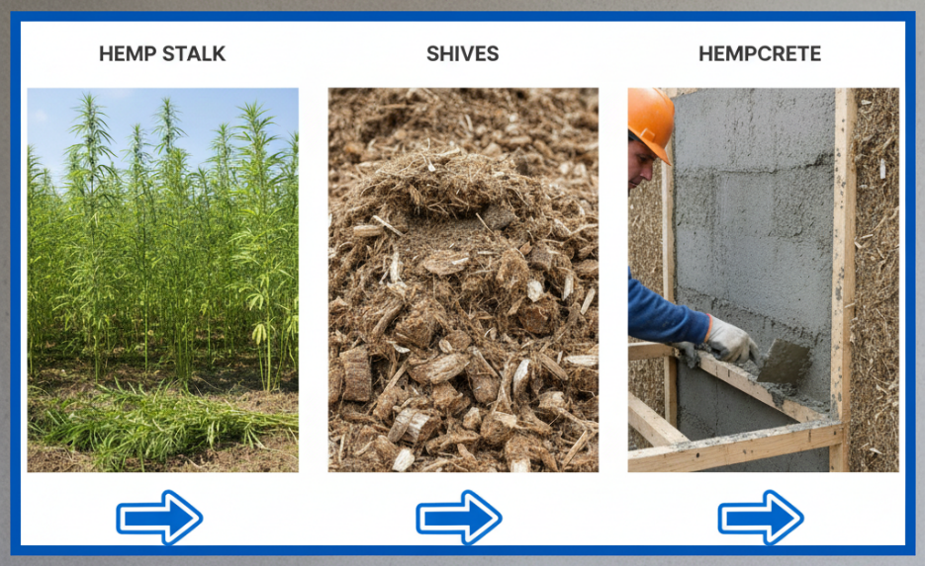
Fig.1: Process flow from hemp stalk to hempcrete Created by: Canvas

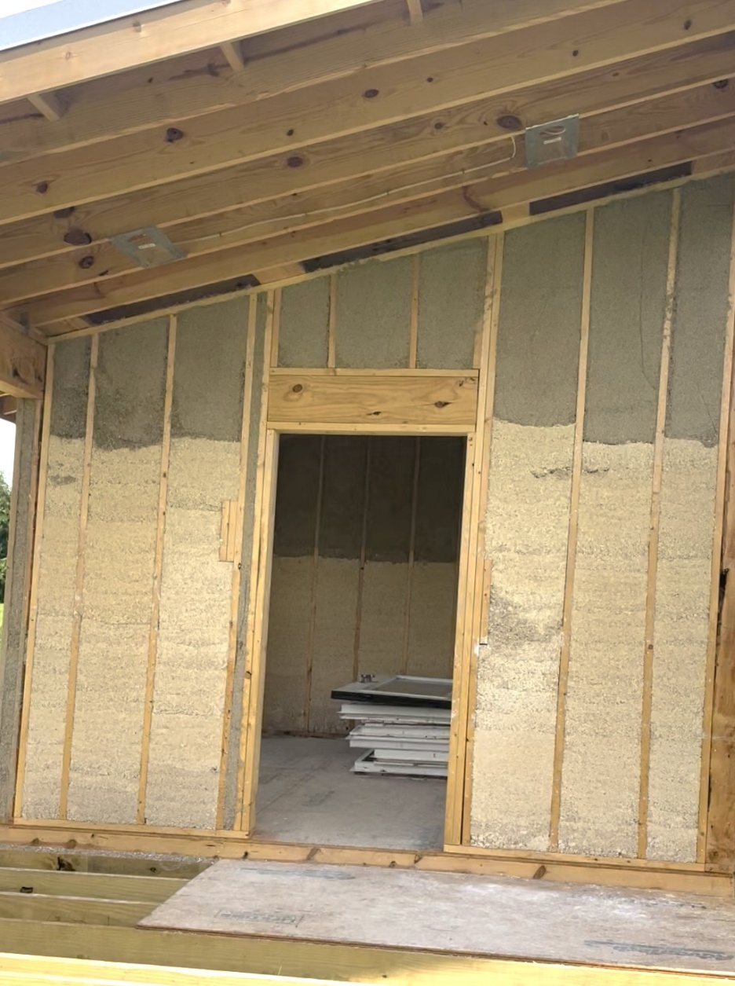
Fig.2: Hempcrete demonstration structure at TSU AREC, Nashville TN

Future Opportunities with Fiber Hemp

Hempcrete is part of a larger effort to position fiber hemp as a driver of sustainable construction, rural development, and industrial innovation. Opportunities include:

- Housing & Infrastructure – Hempcrete provides an affordable, energy-efficient solution for residential, agricultural, and commercial buildings.

- Rural Economic Development – Expanding hemp supply chains creates new revenue streams for farmers, processors, and builders in rural communities.

- Agronomy & Rotations – Integrating fiber hemp into rotations supports weed suppression, soil improvement, and profitability for farmers, while diversifying income sources.

- Environmental Remediation – Integrating hemp into construction markets leverages its dual role as both a soil-cleaning crop and a carbon-storing material.

- Workforce Development – Growth in hemp-based industries opens pathways for training students, tradespeople, and entrepreneurs in advanced green technologies.

- Market Expansion – Universities, government agencies, and private companies are collaborating to scale up hempcrete adoption, standardize codes, and ensure supply chain readiness.

For More Information
- Tennessee State University Hemp Research – https://www.tnstate.edu/agriculture/hemp.aspx
- University of Tennessee Hemp Program – https://utianews.tennessee.edu/hemp/
- USDA Hemp Program – https://www.ams.usda.gov/rules-regulations/hemp
- Tennessee Department of Agriculture (TDA) Hemp Program – https://www.tn.gov/agriculture/farms/hemp-industry.html

Support for this publication was provided by USDA-National Institute of Food and Agriculture through the
Beginning Farmers and Rancher Development Program Grant.
Dean - Dr. Chandra Reddy, Associate Dean for Extension - Dr. Latif Lighari
Tennessee State University is an EEO employer

Contact
For more information on fiber hemp and hempcrete research and development:
Dr. Emmanuel C. Omondi
Assistant Professor of Agronomy & Industrial Hemp Extension Specialist
Tennessee State University
📧 eomondi@tnstate.edu | 📞 (615) 963-5830

