  College of Agriculture, Human & Natural Sciences  Cooperative Extension Program | Indoor Cultivation of Floral Hemp in Modified Rooms  By Dr. Emmanuel Omondi, Industrial Hemp Extension Specialist,  Nicholas Davis and Anand Kumar, Graduate Researchers,  Department of Agricultural Sciences & Engineering  Tennessee State University, Nashville TN

Introduction
Floral hemp grown for cannabinoids such as CBD can be successfully cultivated indoors using modified rooms (e.g., spare bedrooms, garages, warehouse partitions). Compared to greenhouses, the investment is lower, though costs for lighting, ventilation, and climate control are still considerable (Figure 2, 3).

Market volatility in hemp and cannabis has reduced large-scale profitability, but room-scale floral hemp cultivation allows growers to focus on specialty production for high-value buds with consistent quality. Controlled indoor environments also reduce exposure to outdoor pests and diseases.

Life Cycle and Photoperiod Sensitivity
Cannabis, including floral hemp, is a photoperiod-sensitive crop. Long days with extended light promote vegetative growth, while shorter days with equal light and dark hours trigger flowering and bud development.

- Vegetative phase: Typically lasts 3–8 weeks under ≥ 14–18 hours of light daily. Shorter veg phases yield smaller plants and earlier harvests, while longer veg phases result in larger plants and higher yields but higher costs.
- Flowering phase: Triggered by a 12-hour light /12 hour dark cycle and typically lasts 8–10+ weeks, with timing dependent on cultivar and cannabinoid maturity.

Cultivation Practices and Training
- Pruning / Defoliation: Remove crowded leaves to improve airflow and light penetration.
- Training: Topping and canopy-management techniques such as low-stress training (LST) and Screen of Green (ScrOG) promote even light distribution and increase flower yield in confined indoor setups. Topping early in the vegetative stage encourages branching and uniform canopy development.
- Rotation / Renewal: Rotate pots for uniform growth; flush or replace medium to prevent salt buildup.
- Propagation: Clones (Figure 1) are preferred over seedlings for uniform growth, consistent cannabinoid profiles, and predictable performance in controlled indoor environments.
(Univ. of TN Hemp, 2025; N.C. State Univ. Extension, 2021; Penn State Extension, 2025)

Economics and Market Considerations
- Volatility: Wholesale CBD and hemp flower prices swing significantly due to oversupply and regulations.
- Strategy: Focus on premium quality buds and niche buyers rather than bulk commodity markets.
- Costs: Major expenses are lighting, HVAC, electricity, and labor — efficiency is key to profitability.
(Univ. of TN Hemp, 2025; Penn State Extension, 2025)

Key Tips for Growers
- Use 18–24 hours light in veg phase, then 12/12 for flowering (8–10+ weeks) phase.
- Target nutrient ratios by growth stage; monitor pH and electrical conductivity (EC) carefully.
- Maintain strong airflow, consistent sanitation, and humidity control.
- Combine biological, botanical, and chemical tools — don’t rely on one strategy.
- Start with manageable room setups and scale based on market opportunities.

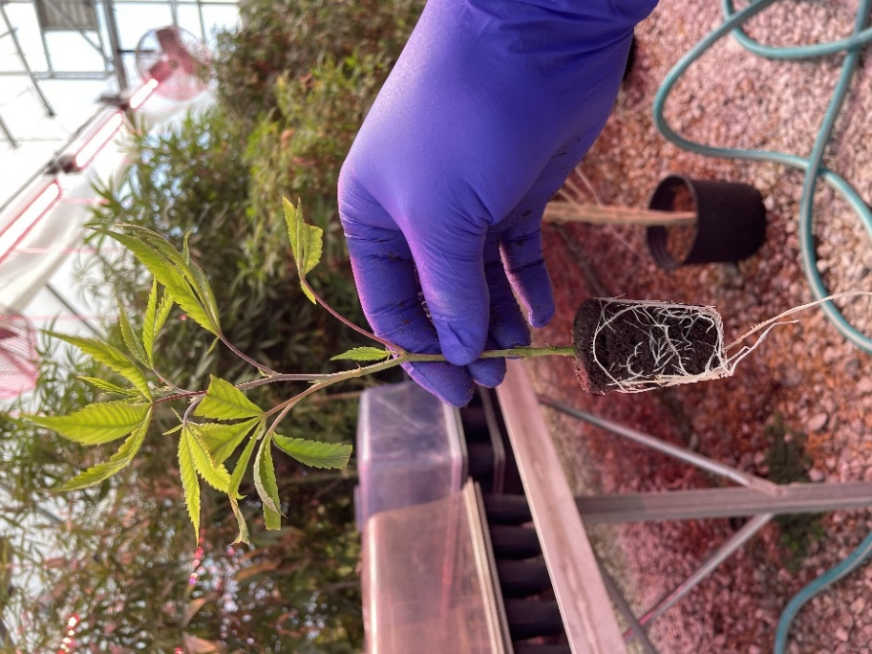

Figure 1: Rooted floral hemp clone used as the preferred source of propagation in modified indoor grow rooms.

Environmental Control (Room-Scale)
- Temperature and Humidity: Maintain 70–85 °F during the day, 59–72 °F at night. Keep humidity around 60–70% during the vegetative phase and 40–50% during flowering to balance plant growth and mold prevention.
- Airflow and Ventilation: Intake/exhaust fans and oscillating fans prevent stagnant air, reduce disease risk, and control odors.
- Lighting and Light Distribution: LEDs are energy-efficient with less heat, HID lights provide strong yields but run hot, and fluorescents are inexpensive for seedlings or small-scale grows. Reflective walls or “grow tents” improve efficiency.
(Univ. of Connecticut, Greenhouse Program, 2025)

Water and pH Management
- Soil: pH 6.0–6.5
- Hydroponics / soilless: pH 5.5–6.0
- EC/ppm: Monitor regularly. Aim for 600–900 ppm in vegetative growth and 900–1,100 ppm in flowering; avoid exceeding 1,100 ppm to prevent salt stress.
- Water quality: Reverse osmosis (RO) or filtered water recommended where mineral buildup is a concern

Pest and Disease Control
Indoor rooms reduce exposure to outdoor pests but enclosed environments can amplify infestations. Integrated Pest

Management (IPM) is essential:
- Sanitation: Quarantine new plants, sterilize tools, clean rooms regularly.
- Biological Controls: Predatory mites, ladybugs, lacewings, beneficial fungi (Trichoderma).
- Botanical /Organic Products: Neem oil, insecticidal soaps, Bacillus thuringiensis (Bt), sulfur sprays, potassium bicarbonate.
Chemical Options: Where permitted, use low-risk pesticides/fungicides labeled for hemp. Always check local regulations.
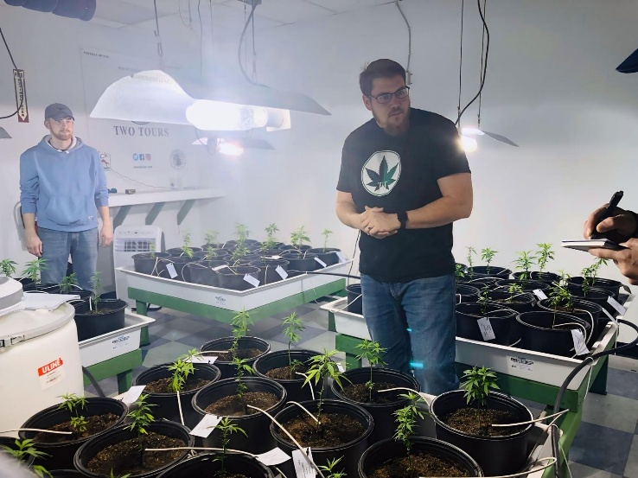

Figure 2: Graduate Researcher, Nicholas Davis in his demonstration indoor operation in Dickson Tennessee

Common Problems: Spider mites, thrips, aphids, fungus gnats, whiteflies, broad mites; powdery mildew, botrytis (bud rot), root rots. (Penn State Extension, 2025).
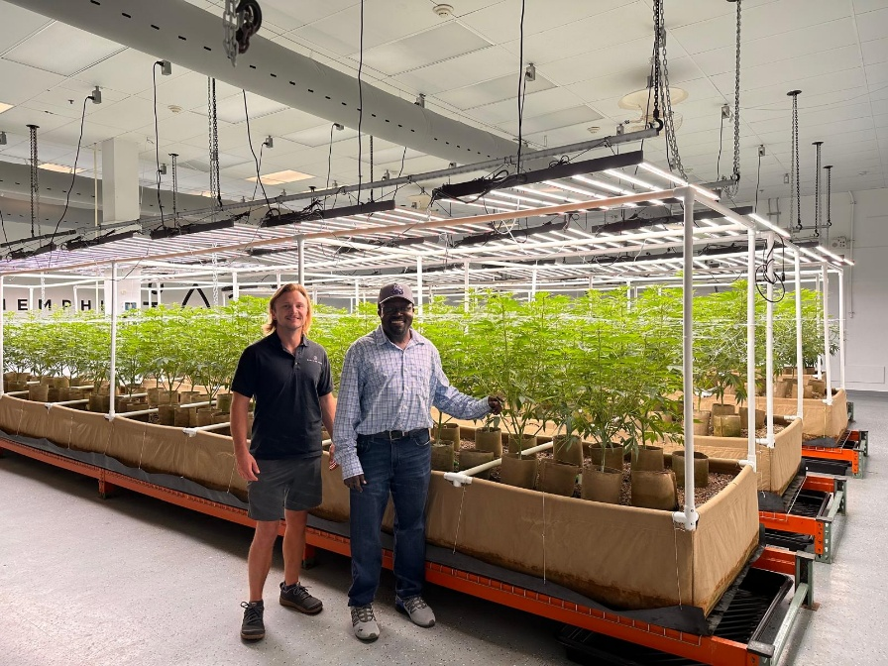

Figure 3: Cameron Heil and Emmanuel Omondi in Ounce of Hope Aquaponics cannabis farm and modified indoor operation that integrates fish farming in Memphis, Tennessee

Nutrient Needs and Fertilizer Recommendations
Growth Stage | Typical N:P:K | Nutrient Focus | Fertilizer Examples* | References
Vegetative growth (3–8 weeks) | 3:1:1 or 3:1:2 | High N for foliage, moderate P and K | Synthetic: General Hydroponics Flora “Grow” (3-2-6), Advanced Nutrients “Grow,” Jack’s 20-10-20.  Organic: Fish emulsion (5-1-1), alfalfa meal (3-1-2), compost tea, worm castings. | Bughee, B and N. Langenfeld (2024). Utah State University
Early to mid flowering (weeks 1–4 of 12/12) | ~1:3 :2 | Increase P and K for bud set, reduce N | Synthetic: GH Flora “Bloom” (0-5-4), Jack’s Blossom Booster (10-30-20), Advanced Nutrients “Bloom.”  Organic: Bat guano (0-10-0), bone meal (3-15-0), seabird guano, kelp extracts. | Davis, J. (2021). Nutritional Guides for Greenhouse Hemp. North Carolina State University
Late flowering / maturation (weeks 5–10+) | ~0:2–3:3 | Minimize N to avoid leafy buds, emphasize K for density and finish | Synthetic: PK boosters (0-50-30), GH KoolBloom, Advanced Nutrients “Overdrive.”  Organic: Sulfate of potash (0-0-50), wood ash (cautious use), molasses. | Kaiser, C.; Cassady, C.; Ernst, M. (2020). Industrial Hemp Production. publications.ca.uk; Penn State Extension, 2025. Industrial Hemp Production. Pennsylvania State University

*Always follow label rates, adjust based on medium (soil vs hydroponics), and monitor EC/ppm to avoid salt buildup.

Reference:
- Penn State Extension. (2025). Industrial Hemp Production. Pennsylvania State University. https://extension.psu.edu/hemp
- Colorado State University Extension. (2024). Industrial Hemp: Reemergence of an Alternative Crop in the U.S. Colorado State University. https://extension.colostate.edu
- North Carolina State University Extension. (2024). All About Hemp. North Carolina A&T State University and NC State Cooperative Extension. https://www.ncat.edu/caes/cooperative-extension/files/all-about-hemp.pdf
- University of Kentucky Extension. (2024). Industrial Hemp Production Guide. University of Kentucky College of Agriculture, Food and Environment. Retrieved from https://hemp.ca.uky.edu
- Oregon State University Extension. (2024). Hemp Nutrient and Fertilizer Management Guide. Oregon State University. Retrieved from https://extension.oregonstate.edu

For More Information
- Tennessee State University Hemp Research
- University of Tennessee Hemp Program
- University of Connecticut Hemp IPM Guide
- Penn State Extension: Indoor Cannabis Production
- Industrial hemp - Cornell CALS

Support for this publication was provided by USDA-National Institute of Food and Agriculture through the Beginning Farmer and Ranger Development Program Grant.
Dean - Dr. Chandra Reddy, Associate Dean for Extension - Dr. Latif Lighari
Tennessee State University is an EEO employer

Contact:
Dr. Emmanuel Omondi
Assistant Professor and Industrial Hemp Extension Specialist
Tennessee State University
Email: eomondi@tnstate.edu | Phone: (615) 963-5830

