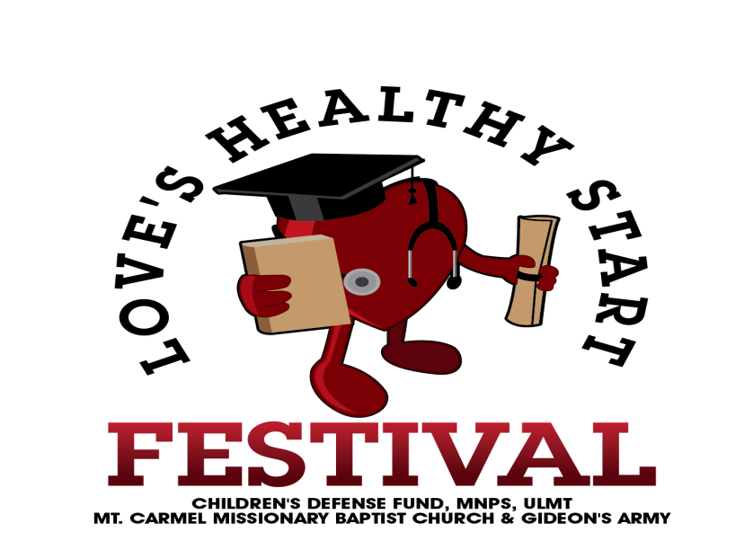
June 5, 2018
Representative Harold M. Love’s Sixth Annual “Love’s Healthy Start Festival” (LHSF) returns to Hadley Park (1037 28th Ave North) on July 28, 2018 from 9:00 am to 12:00 pm. Supporting the festival’s 6th year are sponsors representing a cross-section of our community including Tyson Foods, Tennessee State University, and Metropolitan Nashville Public Schools. We will continue again with last year’s festival theme “Increasing Literacy: One Family at a Time” highlighting activities aimed at preparing youth for their successful return to school on August 7th, as well as, providing opportunities for families to engage in activities and with organizations that support the acquisition of literacy skills. “Reading is Fundamental!”
Backpacks, a cornerstone of the festival, will, again be provided to all school age children in attendance! In addition there will be music, food, and fun along with booths representing the Pearl-Cohn, Whites Creek, and Hunters Lane cluster schools. All of this and more is FREE to the community.
Your organization, ________________________________, has agreed to provide a booth highlighting information important to those in attendance. Please complete the following information and return to, Lorraine Stallworth (Lorraine.stallworth@mnps.org) so that we may assign a table(s) and 2 chairs for the event. This is a rain (TSU Kean Hall) or shine event. We will have limited access to electrical outlets. If you have questions, contact Lorraine Stallworth at 615-500-1091 or Lu Lovette
The deadline for returning this form is July 20, 2018

Name of Organization: _________________________________________________________________
Contact Person: _______________________________________________________________________
Email address: _______________________________ Telephone #:______________________________
Information provided at table: _____________________________________________________________________________________
_____________________________________________________________________________________
Booth needs: ____ table ____chairs (2) ____electrical outlet (limited) ____Other________________
Festival participants will be required to attend several booths in order to receive the backpacks being distributed. Therefore, please be prepared to share information about your organization and its services.
Vendors are encouraged to distribute materials related to this year’s theme, however, No Food Shall be Prepared or Distributed at Individual Booths.

