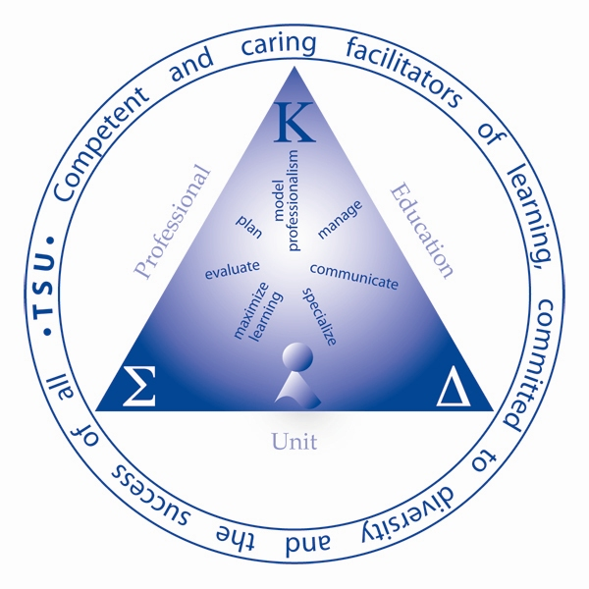



**Tennessee State University**

**Professional Education Unit**

**Department of Teaching and Learning**

**Classroom Management**

**EDCI 3110**

**Instructor**: XXXXXXXXXX

**Phone**: XXXXXXXXXX

**E-mail**: XXXXXXXXXX

**Office Location:** XXXXXXXXXX

**Class Days/Times**: XXXXXXXXXX

**Office Hours**: XXXXXXXXXX

## **Pre-requisites**

Admission to Teacher

## **Required Text(s)**

Evertson, (2009). Classroom Management for Elementary Teachers. (8th ed.). Pearson. New Jersey.

**Catalog Description**

This course addresses methods in the area of classroom management. Knowledge, Skills and Dispositions are emphasized in special methods associated with creating a learning environment that encourages positive social interaction, active engagement in learning and self-motivation.

##### Course Proficiencies*

### Knowledge and Skills

**Dispositions**

Manage

4a1. Exhibits enthusiasm and positive disposition toward the content area and conveys high expectations for success to students.

4a2. Establishes clear classroom standards and expectations for behavior that emphasize self-control, self-discipline, collaboration, and mutual respect among students and teacher.

4a3. Establishes clear classroom standards and expectations for achievement that focus upon content knowledge, engagement in purposeful learning, high academic performance, and ownership of learning.

4b1. Creates a classroom environment that organizes and manages time, space, facilities, and other resources for maximum engagement of students in the content.

4b2. Demonstrates flexibility in restructuring time, space, facilities, and other resources as the situation demands.

Model Professionalism

5b1. Uses data and self-assessments to develop a professional development plan that articulates teaching strengths and identifies priorities for growth within at least one content area of the teaching assignment.

5c1. Engages in dialogue with students, colleagues, parents, administrators and stakeholders and consistently demonstrates respect, accessibility, and expertise.

5c2. Performs assigned duties in a timely manner with a professional disposition.

5c3. Uses appropriate technology to keep accurate records related to instructional and non-instructional responsibilities

**Instructional Strategies**

Lecture

Discussion

Technology (students)

Case Studies

Field Experience

Log/Diary/Journal

Portfolio

Individual Presentations

Group Discussions

Group Presentations

**Field Experience Information**

Level 2

**Expectations and General Information:**

1. **Academic Integrity** - You are responsible for what you achieve in this class; therefore neither cheating nor plagiarism will be tolerated. Any material taken from other sources must be documented. In no case should one represent another’s work as one’s own. This includes information received from others during examinations or submitting another’s assignments, papers, etc. as one’s own. To avoid questions of plagiarism, students involved in collaborative research should exercise extreme caution. If in doubt, students should check with their major professor. In addition to the other possible disciplinary sanctions which may be imposed through the regular institutional procedures as a result of academic misconduct, the instructor has the authority to assign an “F” or a zero for the exercise or examination, or to assign an “F” in the course.
2. **Classroom Conduct** –The instructor has the primary responsibility for control over classroom behavior and maintenance of academic integrity. The classroom instructor can order the temporary or permanent removal from the classroom, any student engaged in disruptive conduct or conduct in violation of the general rules and regulations of the institution. The use of cell phones and text messaging are not allowed in the classroom. If a cell phone rings in class, the student is asked to leave the class for that class period. Assignments will not be accepted if the work is turned more than one day late.
3. **Classroom Attendance** - Students are expected to attend classes regularly and punctually. The instructor will keep an accurate record of class attendance. Excessive absence is defined as no less than one more than the number of times a class meets per week. If a student has excessive absences and does not have an excused absence from the TSU Health Center, or from a doctor, his/her final grade is lowered one letter grade. If a student is tardy four times, without an excuse, he/she will not be counted present for that day. It is the student’s responsibility to withdraw from a course in which excessive absences have been incurred.
4. **Official Course Enrollment** - Students who are not on the official class roll may not remain in class. These students must leave class and may not return to class until they have enrolled in the course and their names show up on the official class roster. Please make sure that you are in the correct section.
5. **Disabled Student Services** – Any student who has a condition which might interfere with his/her performance in class may contact the office of Disabled Student Services. This office is located in room #117 Floyd Payne Student Center. The phone number is 963-7400. They will provide you with a document stating what type of classroom accommodations, if any, are to be made by the instructor. The student is to give a copy of this document to the instructor no later than the end of the second week of class. Failure to do so will result in the instructor making no special accommodations of any kind.
6. **Changes to Course Syllabus** – The instructor reserves the right to make modifications to this syllabus. Any modifications to the syllabus must be clearly communicated to students.

**Tentative Course Schedule**

**Course Assignments**

**Key Assignments**

Portfolio 25%

Philosophy of Classroom Management 25%

Projects 25%

Exams 25%

All entries in the Portfolio must be types!! **No handwritten entries**

Classroom Management Philosopher presentation

Articles (3)

Comprehensive case study

Class routines

Classroom rules with consequences

Classroom Management Portfolio

### Grading System

A =90-100%

B =80-89%

C =70-79%

D =60-69%

F=59%

**Additional Readings/Resource**

**Charles, C. & Senter, G. (2005). Elementary Classroom Management. Pearson. Boston.**

**Danfort, S. & Boyle. J. (2000). Cases in Behavior Management. New Jersey. Prentice Hall.**

**Philosophy**

The philosophy of classroom management must be at least 4 pages (12 font double spaced Times New Roman), and must contain theorist and references to support your view of the theory (minimum of 3 theorist). It must be APA formatted with reference pages that are not included in the 4 page minimum. It also must contain a cover page with no hand written entries.

**Articles**

Select three articles related to classroom management (2 behavioral and 1 organizational) write a brief summary to be presented in class and turn in the article with the summary.

**Case Study**

You will be given a student with a particular behavior or problem you must design 3 different types of assessments to be used with the student and fill in the results. Write the students personal information and history and it must be related to the behavior given. After filling in the assessments analyze the results and write a summary. Then devise a plan to be used to decrease or eliminate the behavior. Repeat the previous assessments and include a student self assessment analyze the results write a summary describing if your plan was successful. If your plan was not successful then state what you may try next.