
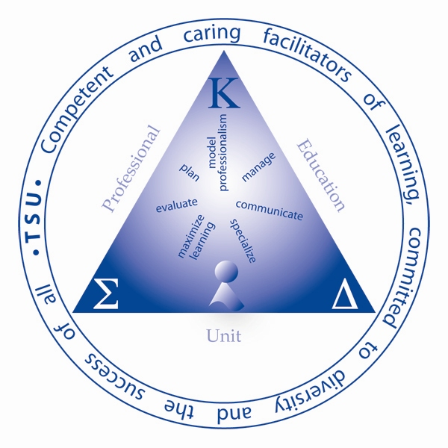
Tennessee State University
Department of Teaching and Learning
EDCI 5820/6820
Advanced Mathematics in the Elementary School

Instructor: XXXXXXXXXX
Phone: XXXXXXXXXX
E-mail: XXXXXXXXXX
Office Location: XXXXXXXXXX
Class Days/Times: XXXXXXXXXX
Office Hours: XXXXXXXXXX

Pre-requisites

- Admission to Graduate School

Required Text(s)

Van de Walle, John A. (2007). Elementary and middle school mathematics: Teaching developmentally. (6th ed.). Boston, MA: Allyn & Bacon.

Catalog Description

Current developments in elementary mathematics programs. Emphasis is placed on “modern math,” curriculum, classroom methods and techniques, evaluation procedures, and teacher training.

Field Experience

Observations and reflections outside the class will provide the learners with opportunities to balance their own understanding of theory and practice. Students in the course who are currently in Pre-k-8 teaching situations should assist others in developing an understanding of pedagogy applied to practice.

Course Proficiencies (Content Knowledge, Skills, Dispositions)

Content Knowledge
- Knowledge of how to teach through problem solving.
- Knowledge of how to build assessment into instruction.
- Knowledge of how to incorporate technology into mathematics lessons.
- Understanding of the principles and standards for school mathematics.

Skills
- Create and implement a math unit that can be used in a K-8 classroom.
- Participation in action research studies that will enhance math instruction.
- Ability to identify reading materials that can be integrated in math lessons.
- To develop a math philosophy that represents a diverse and changing society.

Dispositions
- Students will have an appreciation for different learning styles (e.g. auditory, visual and kinesthetic).
- Students will develop an appreciation for reading professional journals.

Portfolio Information (Artifact, Scoring Rubric)

Artifact(s) for Portfolio
TBA

Scoring Rubric(s) for Artifact(s)
TBA

Expectations and General Information:

- Academic Integrity - You are responsible for what you achieve in this class; therefore neither cheating nor plagiarism will be tolerated. Any material taken from another work must be documented, and in no case should one represent another’s work as one’s own, this includes information received from others during examinations or submitting another’s assignments, papers, etc. as one’s own. Students involved in collaborative research, to avoid questions of plagiarism, should exercise extreme caution. If in doubt, students should check with the major professor. In addition to the other possible disciplinary sanctions which may be imposed through the regular institutional procedures as a result of academic misconduct, the instructor has the authority to assign an “F” or a zero for the exercise or examination, or to assign an “F” in the course.
- Classroom conduct – The instructor has the primary responsibility for control over classroom behavior and maintenance of academic integrity, and can order temporary removal or exclusion from the classroom of any student engaged in disruptive conduct or conduct in violation of the general rules and regulations of the institution.
- Official Course Enrollment - Students who are not on the official class roll may not remain in class. These students must leave class and may not return to class until they enroll in the course and their names show up on the official class roster. Please make sure you are in the correct section.
- Disabled Student Services – Any student who has a condition which might interfere with his/her performance in class is required to contact the office of Disabled Student Services. This office is located in room #117 Floyd Payne Student Center. The phone number is 963-7400. They will provide you with a document stating what type of classroom accommodations, if any, are to be made by the instructor. The student is to give a copy of this document to the instructor no later than the end of the second week of class. Failure to do so will result in the instructor making no special accommodations of any kind.
- Students are to report to class on time and stay for the duration of the class session.
- No cell phones or communication devices may be out at anytime.
- No children will be allowed to attend any class sessions.
- Late assignments will be accepted but points will be deducted.
- No late assignments will be accepted will be accepted without an excused absence.
10) Please do not e-mail assignments unless permission of the instructor is given.

Course Requirements
Philosophy /Theorist 30 points
Interview a math teacher 30 points
Math Website Presentation 30 points
Math lesson using math manipulatives/models 50 points
Journal Article (APA)/Presentation 40 points
Math Integrated Thematic Instructional Unit 100 points (=20 points x 5 lessons)
Chapter Summaries /Class Discussions 100 points (=20 chapters x 5)
Research Paper (APA) Presentation 50 points
Midterm 50 points
Final 50 points
_______
530 points

Grading System

A = 90% 477 points
B = 80% 424 points
C = 70% 371 points
D = 60% 318 points
F = <60% less than 318 points

The course instructor reserves the right to make changes in the course outline. Any such changes will be announced during class meetings. It is each student’s responsibility to be aware of any such announced changes.

Important Dates
1/15 Introduction/Syllabus/Homework
1/22 Discuss Chapters 1&2/Activity
1/29 Discuss Chapters 3&4/Activity
2/5 Discuss Chapters 5&6/Journal Article Due
2/12 Discuss Chapters 7&8
2/19 Discuss Chapters 9&10/Interview Due
2/26 Discuss Chapters 11&12/Philosophy Due
3/3-9 Spring Break
3/11 Midterm Chapters 1-12
3/18 Website Presentations
3/25 Discuss Chapters 13&14/Web Presentations
4/1 Discuss Chapters 15, 16 &17/Portfolio Due
4/8 Discuss Chapters 18, 19 &20/Math Lessons
4/15 Unit team planning/Research
4/22 Math Lesson Presentations/Research Paper
4/29 Final (Chapters 13-20)/Portfolio

Additional Readings/Resources
Journal for Research in Mathematics Education
Mathematics Teaching in the Middle School
School Science and Mathematics
Teaching Children Mathematics

